**Final Capstone Project: Phoenix Home Price Predictor**

**Dawn Belbin**

**College of Science, Engineering, & Technology, Grand Canyon University**

**DSC-580 Designing and Creating Data Products**

**Edward Ofori**

**March 1, 2023**

Capstone Project Proposal 4

Data Repository and App 4

Project Overview and Project Objectives 4

Background 4

Project Objectives 4

Challenges 5

Benefits and Opportunities 5

Project Scope 5

Breakdown of work 5

Project Completion 6

Project Controls 6

Project Schedule 8

Cost Estimates 8

Issue Log 9

Requirements Analysis 10

Use Case 10

System Design 10

Technical Requirements 11

Data Science Model 11

Report Definition and Layout 12

Security 16

Model Pipeline Design 17

Design Planning Summary 17

Overview of Design Concepts 17

Deliverable Acceptance Log 18

Detailed Model Pipeline Design 19

Data Sources 19

Dataset Types and Formatting 19

Data Cleaning Procedure 19

Initial Data Exploration and Visualization 20

Data Model Used and Its Nature 21

Methodology for Interpreting the Analysis Results 21

Configuration Changes Required to Develop and Implement Proposed Solution 22

Security 22

Hardware and Software Technologies 23

Implementation 23

System Entities 23

Functional Requirements 24

Source Code Listing 25

Source Code for Building Streamlit App 57

Implementation Plan 66

Performance Analysis 68

Testing 68

Module Test Cases 69

Requirements Testing 74

System Testing 75

Operation and Maintenance 75

User Guide 76

Home Page 77

Map of Historical Home Sales 79

Historical Prices by Zip Code 80

Statistics by Home Sales 83

Correlation of Home Features 85

Calculator 86

Troubleshooting 88

FAQ’s 88

Help and Contact Details 90

System Administrator Guide 91

Adding New Data 91

Updating the Model in Python 93

Updating the Model in GitHub 93

Updating the Model in Streamlit 95

References 96

# Capstone Project Proposal

## Data Repository and App

The data repository and application for the project can be found in GitHub and Streamlit.

GitHub: <https://github.com/dbelbin/Capstone.git>

Streamlit App: <https://dbelbin-capstone-app-mp6x0y.streamlit.app/>

## Project Overview and Project Objectives

When looking at real estate as a casual investor, it is hard to make sense of what features people see the most value in at a given point in time.

## Background

There are always questions that arise in real estate about what people find value in, what features have the greatest impact on price. Even though real estate is unpredictable at the moment, making predictions less accurate, there are still certain features that will have a greater impact on price than others. As someone who would like to invest more in real estate, the purpose is to determine what features are most impactful to the overall price and therefore worth investing in.

## Project Objectives

The objective of this project is to provide the casual investor with a model that is able to predict the price of a house based on different features. This will give an investor the ability to understand what the predicted value of a house with certain features is to help understand whether a home that is currently for sale is a wise investment. The project is limited to houses sold at $500,000 and below in the city of Phoenix over the previous 1.5 years. For example, what is the expected difference in price when a property has a pool or not or is in an HOA or not. This will allow the causal investor to make a more educated decision when buying, selling, or even improving real estate.

## Challenges

* Availability of Data
* Narrowing the features to evaluate
* Understanding changing behaviors based on macro-economic events such as interest rates and demand
* Scalability to include other regions or price brackets

## Benefits and Opportunities

Using the data provided by the model to make educated investments based on what features are present. This includes improvements being made to property such as an addition to a property or building a new pool to determine if the investment will be worth the cost.

## Project Scope

To build a model that analyzes the relationship between different real estate features and determines which features have the greatest impact on price or value.

## Breakdown of work

* Research the topic
* Research and review similar projects
* Literature review
* Identify the data
* Gather the data
* Exploratory Data Analysis
* Build multiple models
* Evaluate models
* Select optimal model
* Build model report to graphically show results

## Project Completion

The project’s success should be measured by having an accurate model that is able to predict which features of a house are most important to the house at $500,000 and below in the city of Phoenix. The project will have visualizations that present the results.

## Project Controls

|  |  |  |  |  |
| --- | --- | --- | --- | --- |
| **RISK MANAGEMENT** | | | | |
| **Event Risk** | **Risk Probability (high, medium, low)** | **Risk Impact** | **Risk Mitigation** | **Contingency Plan** |
| Previous 5 years of data | Medium | The length of time in historical analysis would need to be shortened | Use multiple data sites to gather maximum amount of historical data | Limit the data to previous two years versus the original objective of 2-5 years. |
| Amount of data available in near past due to low number of houses sold at $500,000 or less versus five years ago | High | This could create a bias in data results as there are less houses sold within the price bracket now versus five years ago. | During data exploration analysis, compare the available sales data within the price brackets to ensure that the data is not skewed towards one time period | Create separate models by calendar year in order to see the differences over time versus using data in one model. |
| Data is hard to scrape from the real estate sites | Low | Unable to get enough reliable data will impact the results of the project | Use multiple data sites to gather maximum amount of historical data | Manually download data if available from real estate sites |

This section is to log any changes that occur in the project design once this milestone is completed. This includes any changes that arise from the any known or unknown risks or issues that arise during the capstone project. Below is an example of a possible change that may occur.

## 

|  |  |  |  |  |  |  |  |  |
| --- | --- | --- | --- | --- | --- | --- | --- | --- |
| **Change Control Log** | | | | | | | | |
| **ID** | **Change Description** | **Priority** | **Originator** | **Date Entered** | **Date Assigned** | **Evaluator** | **Status** | **Date of Decision** |
| 1 | Only 1.5 year of data retrieved due to hard to scrape sites | High | Dawn | 10/01/2022 | 10/01/2022 | Dawn | Completed | 10/01/2022 |
| 2 | Reduced from Maricopa County to include only the City of Phoenix due to scraping/data gathering issues | High | Dawn | 10/01/2022 | 10/01/2022 | Dawn | Complete | 10/01/2022 |
| 3 | Manually scrape versus using a scraper due to bot detection on the site that blocks scraping. The use of a paid version that rotates IP addresses was limited to the same quantity that could be manually exported without having the data formatted | High | Dawn | 10/15/2022 | 10/15/2022 | Dawn | Complete | 10/15/2022 |
| 4 | Change from Tableau or Power BI for visualizations to Streamlit which integrates with Python | Medium | Dawn | 11/20/2022 | 12/01/2022 | Dawn | Complete | 12/01/2022 |
| 5 | Keep the data features intact versus combining into groups after exploring the data and finding that the data groupings did not correspond well with the data, and it would make it difficult for an end user to use | Low | Dawn | 11/19/2022 | 11/19/2022 | Dawn | Complete | 11/19/2022 |

This project is a solo project; therefore, the roles and responsibilities are mine.

|  |  |  |  |
| --- | --- | --- | --- |
| **Roles and Responsibilities** | | | |
| **Name** | **Team** | **Project Role** | **Responsibility** |
| Dawn Belbin | None | Owner/Author | Owner/Author |
|  |  |  |  |

## Project Schedule

|  |  |  |  |
| --- | --- | --- | --- |
| **Milestone description** | **Start** | **Days** | **End** |
|  |  |  |  |
| **Milestone 1 Project Proposal and Requirements Analysis** | | 55 |  |
| Rough Draft documentation/deliverables | 8/3/2022 | 7 | 8/10/2022 |
| Project Proposal | 8/5/2022 | 14 | 8/19/2022 |
| Research Topic | 8/17/2022 | 14 | 8/31/2022 |
| **Milestone 2 Project Pipeline Design** |  | 55 |  |
| Collect Data | 9/1/2022 | 14 | 9/15/2022 |
| System Design Specifications | 9/8/2022 | 14 | 9/22/2022 |
| Build Models | 9/15/2022 | 14 | 9/29/2022 |
| Test Models | 9/15/2022 | 21 | 10/6/2022 |
| Choose Optimal Model | 9/30/2022 | 24 | 10/24/2022 |
| **Milestone 3 Implementation** |  | 55 |  |
| Create Implementation Plan | 10/27/2022 | 55 | 12/21/2022 |
| Create presentation/graphical interface | 10/27/2022 | 55 | 12/21/2022 |
| **Milestone 4 Performance Analysis and Presentation** | | 55 |  |
| Performance Analysis | 1/5/2023 | 55 | 3/1/2023 |
| Digital Poster | 1/5/2023 | 55 | 3/1/2023 |
| Presentation | 1/5/2023 | 55 | 3/1/2023 |

## Cost Estimates

This project will utilize the open-sourced software Python and the included libraries and the free version of Streamlit. There only estimated cost is associated with the pro version of GitHub that is the repository for this project. With this project and as well as other personal projects, I have used the maximum allotted memory and have purchased the pro version. This cost is $9 per month.

## Issue Log

The issues log will be used to account for any issues that arise. The issues may be related to a potential risk or a yet unknown risk. The log will give visibility to any issues that arise as the project continues and how the issue is resolved. An example of a potential issue is logged below.

|  |  |  |  |  |  |  |  |  |
| --- | --- | --- | --- | --- | --- | --- | --- | --- |
| **ISSUES LOG** | | | | | | | | |
| **ID** | **Issue Description** | **Project Impact** | **Action Plan/Resolution** | **Owner** | **Importance** | **Date Entered** | **Date to Review** | **Date Resolved** |
| 1 | Previous 5 years of Data from risk log | Minimum | Redfin and Zillow both have bot blockers, this requires a paid scraper that rotates IP addresses to scrape. The service is expensive and limited to the data that is also available to manually download. The manual download keeps the data in a standard format | Dawn | High | 10/01/2022 | 10/15/2022 | 11/15/2022 |
| 2 | Manually downloading the data versus being able to scrape requires need to scale back the area covered by the data | High | Reduced scope from all of Maricopa County to just the zip codes within the city of Phoenix | Dawn | High | 10/01/2022 | 10/15/2022 | 11/15/2022 |
| 3 | Uploading large files to GitHub cloud | High | The model data needed in the pickle file for Streamlit was too large to pass. The data could be kept in Streamlit, but to ensure that an update made in Python flowed from start to finish, git-lfs was used | Dawn | High | 11/30/2022 | 12/02/2022 | 12/2/2022 |
| 4 | GitHub memory issue | High | Research the memory issues and determined that because I have other projects in GitHub the free version is not enough and requires the Pro version | Dawn | High | 12/21/2022 | 1/1/2023 | 1/1/2023 |
|  |  |  |  |  |  |  |  |  |

# Requirements Analysis

## Use Case

Use Case 1:

Download data from real estate site including sale data, sale price, zip code, number of bedrooms, number of bathrooms, square footage of house, square footage of lot, HOA Y/N, Pool Y/N, age of house, combined with a dataset that has the posted 30 year mortgage rates at the time of the sale.

Using the data retrieved, build a model that predicts the value of the house based on the input of the user. The user can visualize the underlying data of the model and use this to prove or disprove the hypothesis of what features impact the price of a house the most. The visualization will give the user the ability to select an area or zip code and see a dashboard that shows the importance of the features. Specific features can be selected to view the historical price over the period of the data.

## System Design

Top-Down Approach to System Design

## Technical Requirements

The technical requirements for this project include a PC with internet access, Python and GitHub and Streamlit. The python libraries to be used include but not limited to pandas, NumPy, matplotlib, TensorFlow, sklearn, math, and datetime. The end user will only need internet access and the URL associated with the Streamlit model.

## Data Science Model

Create visualizations to support or contradict the hypothesis

Evaluate the models and chose the optimal model

Build multiple models both machine learning and neural network and compare accuracy

Gather data from Redfin by manually downloading the sale data for Phoenix all data will be quantitative data or converted to quantitative data if necessary

Review the data to determine what features are available in the data. Any data that is binary Y/N will be converted to numeric

Exploratory Data Analysis: Look for outliers and determine which features to include in the model

## Report Definition and Layout

The output for the project will include multiple visualizations contained within an app that the user can access. The first visualization is a static map that shows the area covered by the data used to create the model.

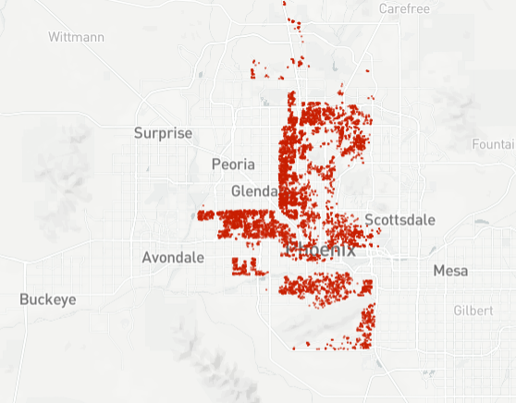

The second report visualization will include the ability to view the median home prices by zip code(s) and the corresponding trend line associated with the selected zip codes. A scrollable data table will also be available with property details.

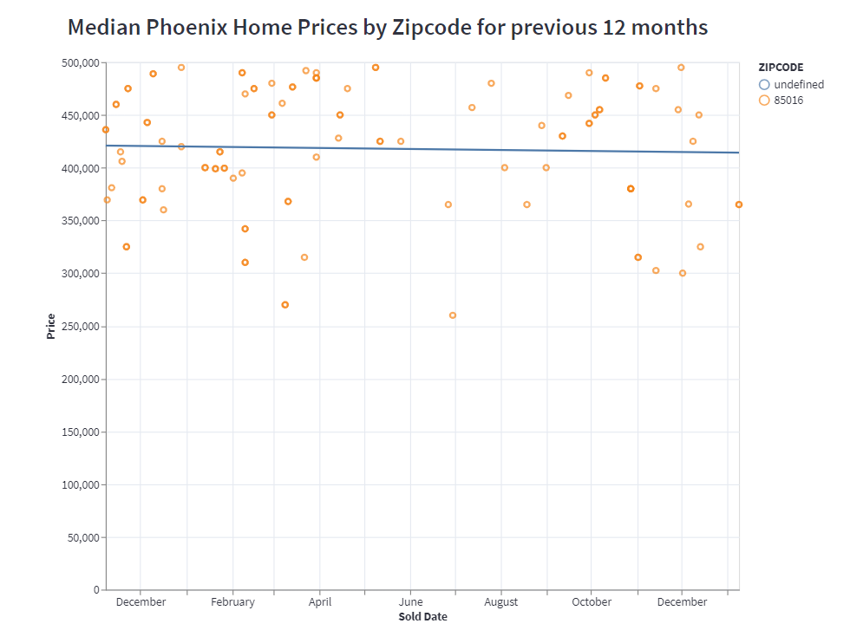

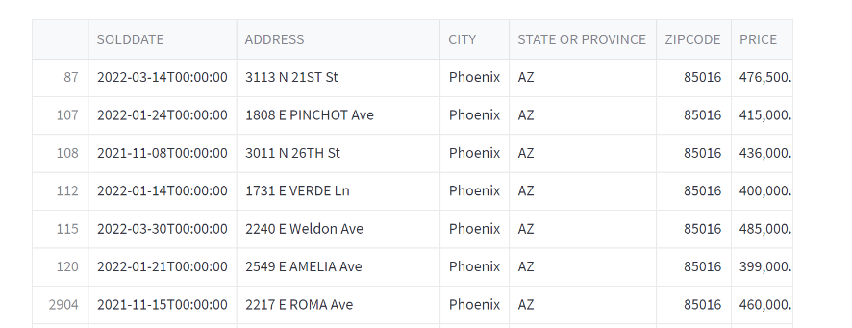

The third report is a statistical report that breaks down the median price, bedrooms, bathrooms, square footage, lot size, year built and 30 year mortgage rate by zip code, HOA Y/N, and Pool Y/N.

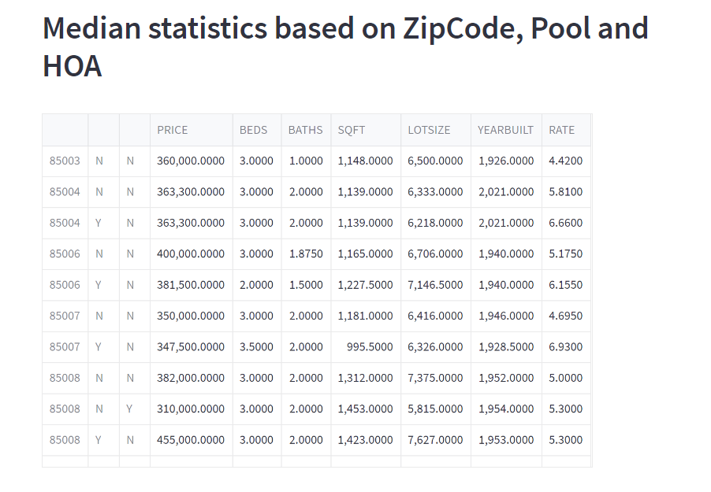

The fourth report is also a statistical report that provides a correlation of home feature visualization.

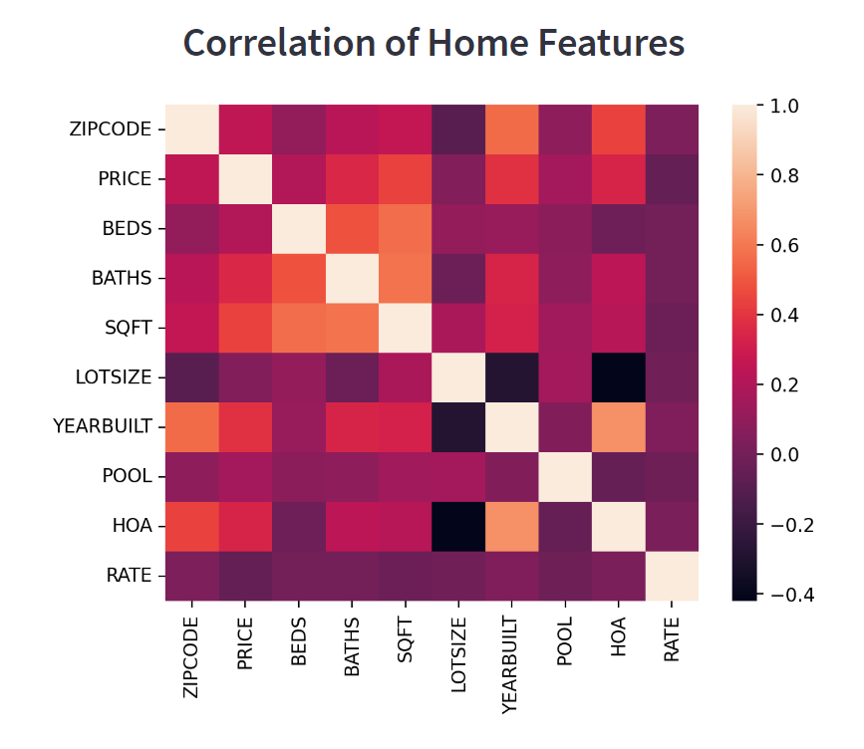

The last visualization is an interactive price predictor based on input data. This allows the user to enter details that are then processed through the model to predict a house price.

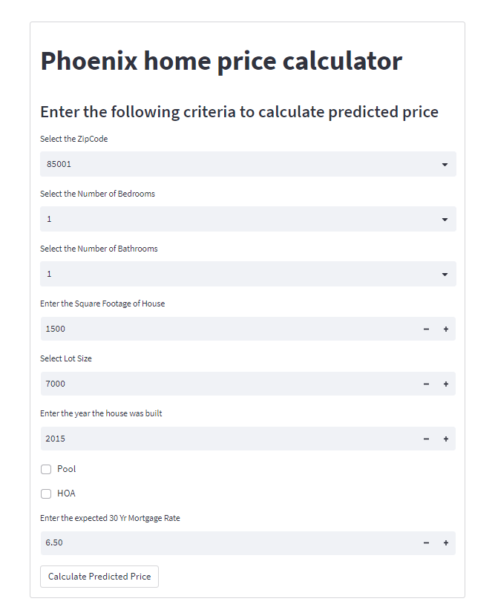

## Security

This data is publicly available data and does not contain any protected personally identifiable information, because of this, there are no security measures that are necessary to ensure the protection of the data. The access to the Streamlit app is limited to anyone that has the URL for the data product.

# Model Pipeline Design

## Design Planning Summary

There are always questions that arise in real estate about what people find value in, what features have the greatest impact on price. Even though real estate is unpredictable at the moment, there are still certain features that will have a greater impact on price than others and this changes over time as the market changes. As someone who would like to invest more in real estate, the purpose is to determine what features are considered more valuable and therefore worth investing in. The project will look at properties sold in the city of Phoenix over the previous two years with a price point of $500,000 and below and help the casual investor understand where people are willing to invest, is it a pool versus a larger backyard or more bedrooms etc. and does this change over time. This will allow the causal investor to make a more educated decision when buying or selling real estate.

## Overview of Design Concepts

The design for this project will be a model that is able to predict which features of a house will be most impactful to a house price in Phoenix, as well as show a time series of how house features have impacted price in the past. The model will be built in Python. The process will include merging the collected datasets together into one dataset. Once the raw dataset has been created, the data will be examined by performing exploratory data analysis on the data looking for any outliers where the sale price of the property falls outside of an acceptable range. An example of this is the available data does not show if a sale was a private sale, which often occurs between family members and therefore can create an outlier with a below normal sales price. Any missing data will be examined and determined if the data should be excluded, or a value inferred for the missing data. Features will be created that will combine features together into ranges such as three bedrooms and less or four bedrooms and greater and will be converted into numeric or binary values using one hot encoder or a binary 0,1 for yes/no features. Once the new features have been created, the new dataset will be split into 3 with a training dataset, a testing dataset, and a validation training dataset. Once the model is fitted to an acceptable accuracy, an interface with either Tableau or Power BI will be used to visualize the data.

|  |  |  |
| --- | --- | --- |
| Deliverable Acceptance Log | | |
| **ID** | **Deliverable Description** | **Comments** |
| 1 | Identify available data | Data is available on many different real estate sites. For ease of processing, the data will be scraped/downloaded from the Redfin website. |
| 2 | Identify features | Using the data available on the website, selecting the different features that are available for houses that have sold. |
| 3 | Limit the data to city of Phoenix only | To simplify the project, only using the city of Phoenix for data. The model could be scaled in the future to include other areas, however due to time constraints the original model will be built on a smaller scale. |
| 4 | Examine and clean the data | The data needs to be examined, analyzed, and cleaned to create the optimal dataset. |
| 5 | Create new features | Once the dataset has been analyzed and cleaned out outliers, new features must be created from the data to better fit within the model. |
| 6 | Create and fit model | Consider multiple model types for time series analysis to determine which model is optimal for the project. |
| 7 | Evaluate the models | Looking at the different models, determine the optimal model for the project based on the MSE and MAPE metrics. |
| 8 | Build visualization | Build the visualizations of the data that will be used to show how the features are impacting price. |

## Detailed Model Pipeline Design

### Data Sources

Although real estate data is available on many different websites, in order to maintain consistency of what is and is not reported across the sites, this project is sourced from Redfin.com for the real estate data and from Freddie Mac for the mortgage rate data.

### Dataset Types and Formatting

The data will be in multiple csv files retrieved from the Redfin website which allows filtered data to be downloaded with specific public data. The maximum size of each download is 350 properties. The format of the data includes a combination of text and numeric fields. The mortgage rate data is an excel spreadsheet download.

### Data Cleaning Procedure

The initial data cleaning will involve combining the data files together as the downloads are in multiple files. By using the data directly from the Redfin downloads, the format of each file is consistent. The data is combined using glob and append in Python, once the initial data file is created that initial steps of the data cleaning process include looking at the first five rows of data to get an understanding of how the data is presenting itself in Python. The next step is identifying any column that had a null value and the number of null values within each column. This led to removing any rows of data that had a null MLS# as these represent private sales which will skew the model results. This removed the majority of null values from all columns. The remaining null values in the beds, bath and lot size were identified and these rows were also removed as these missing features will have an impact on the model. The next step involves scanning for duplicates using the MLS number. Any duplicates found will be removed. The HOA $/month feature was used to build a new binary data feature to identify if the property had an HOA or not. The Pool Y/N column was also converted to a binary field. The columns were renamed, and the sold date was converted into a proper date field. The data was then scrubbed to only include houses that sold for less than $500,000 and within the city of Phoenix or zip codes less than 85099. The cleaning of the mortgage rate data is taking the weekly data in excel and pushing that down to a day level prior to pulling the data into Python.

### Initial Data Exploration and Visualization

Using the different Python libraries such as Numpy, Pandas, Matplotlib, Seaborn etc., the data is summarized and described to see the range of data for each of the features. Box plots identified outliers in the house sold price. Any house that sold for less than $220,000 was removed from the analysis as an outlier. Scatterplots were used to show the relationship between house square foot and price, number of bedrooms and price, number of bathrooms and price, lot size and price, year built and price, and the 30 year mortgage rate and price. A histogram was also used to show the distribution in the number of bedrooms and to identify any outliers. The boxplot identified six or more bedrooms and one bedroom as outliers to be removed. One step further was to also compare the box plots for each number of bedrooms and price to identify homes that sold for less than $250,000 with more than three bedrooms were also outliers. A histogram of the number of bathrooms shows the distribution of bathrooms and the boxplot showed outliers. Although there are outliers in the number of bathrooms, the majority of homes have two bathrooms and therefore anything above or below two becomes an outlier. It is acceptable that older homes may have only one bathroom and some homes may have up to four bathrooms. The only rows removed are those that had 0.5 bathrooms. The boxplot of the lot size showed a large variation in size, which may be from how the data was originally entered. After research on both a reasonably high and low lot size. Any property with a lot size greater than 15000 sqft or less than 3500 sqft were removed from the data. This still leaves some homes as outliers in the higher end, but within range of acceptability. The box plot of the year built feature shows outliers less than 1915. These homes were removed from the model data. A heatmap is used to show the correlation between variables as well as the corresponding correlation value.

### Data Model Used and Its Nature

The initial proposal was to compare multiple models and evaluate these models based on their R2 and MAE. The dataset was split into two data sets, 80% for training and 20% for testing prior to building the models. The model evaluation included an initial build of many models including: linear regression, XGBoost Regression, KNeighbor Regression, Random Forest Regression and ANN, the model with the highest their R2 and lowest MAE was the Random Forest Regression model. Once the optimal model was identified, a GridSearchCV was used to tune the model and find the best parameters to use.

### Methodology for Interpreting the Analysis Results

The Random Forest Regression model resulted in an R2 value of 0.80 and an MAE of 15,932. This means that the features selected for the model account for 80% accuracy in predicting the sale price. The MAE shows that that mean average error is approximately $16,000 on a home valued between $250,000 and $500,000 the average error I between 3-6% of the predicted value. There are many things that can be part of the additional 20% that would make the model more accurate, but these may involve more qualitative features such as interior/exterior colors, neighborhood homes, school ratings, proximity to work or family, need to move, or house inventory. Each buyer may have very specific reasons for choosing a house that cannot be easily captured by a model, therefore the 80% accuracy is a good initial predictor of a house value that can be used as a guide before viewing or purchasing a property.

### Configuration Changes Required to Develop and Implement Proposed Solution

The configuration changes included moving away from scraping software (ParseHub) as Redfin and Zillow both have terms and use that restrict the use of scaping by bots. Redfin provides a download feature that will download public data in a CSV format. The second configuration change was changing the final visualization tools to be used for the product. The initial plan was to use Tableau or PowerBI, as the project progressed, it was determined that Streamlit would integrate the best from Python and GitHub making it a seamless process to use and maintain the model.

### Security

The data is available on many different websites and is public data. The data downloaded using Redfin’s download process does not contain any protected or proprietary data therefore data security is not an issue. The model is stored in a data repository of GitHub that does not have any other collaborators allowed, this will protect the code from any changes. The final data product is contained on Streamlit which is using a single sign-on connected to GitHub for accessing the data and model. Streamlit offers security for the app and the security is set to only allow specific users to view the app.

### Hardware and Software Technologies

|  |
| --- |
| **Hardware and Software Technologies Used** |
| 1 – Computer |
| 2 – Excel |
| 3 – Python and all associated libraries |
| 4 - GitHub |
| 5 – Streamlit |

# Implementation

## System Entities

The project was completed using Python and its associated libraries, the compile, clean, train, test and deploy the model.

Within the project the data is gathered through manually or systematically scraping the Redfin website. The data is located in multiple csv files that are combined in the first portion of the model using the glob function to read all the files from the directory they are stored on to create and append a dataframe called ‘df’ that has the raw data from the scrapes. After initial observations of the data, the dataframe is condensed and the usable columns of data are combined to create another dataframe called ‘data’. Exploratory analysis is completed on this dataset as well as cleaning, scrubbing and removal of any identified outliers. This dataframe is available for analysis in the final app to show additional features such as address, city, sold date, mls#, latitude, and longitude. The final selected features that are used in the model are saved to the ‘model_data’ dataframe. Within the dataframes, the column headings were changed to be shorter and data types updated to ensure that the correct columns were one hot encoded. Once the model was completed, additional python pages were created to support the Streamlit app creation and contain functions that are created to interact with the data and the model and show visually on the app. On the first page, the load_data function is defined and used to load the pickled data file to be used on analysis contained on the page. The show_page1 function is declared to build a scatterplot on a map of the data points contained within the model. On the second page another load_data function is defined to use be data and be able to show statistical measurements of the data. The show_page2 function is used to define what is showing on page 2 and passed to the main app page. The prediction page contains a load_model function to bring in the trained and tested model. The show_prediction function defines the input values for the model that must be entered and contains the one_hot_encoder transformer and standard scaler to convert the input data as well as the loaded model.

## Functional Requirements

* The system will allow users to explore multiple visualizations of the house features sold in Phoenix over the last year. This will include being able to filter by zip code and see a scatterplot of the sales as well as the home details.
* The system will allow users to see statistics on home sales such as median house price per zip code or number of bedrooms.
* The system will allow users to enter input data to predict what the price of the house will be to give investors ideas of what areas and features impact price within a given zip code

## Source Code Listing

Below are screenshots of the source code. This is also available as attached PDF files.

The suggestions made during the review process in week 5 revolved around the user interface and to ensure that the interface included interactive colors and multiple features. These can be found in the code for the Streamlit app and viewed on the app.

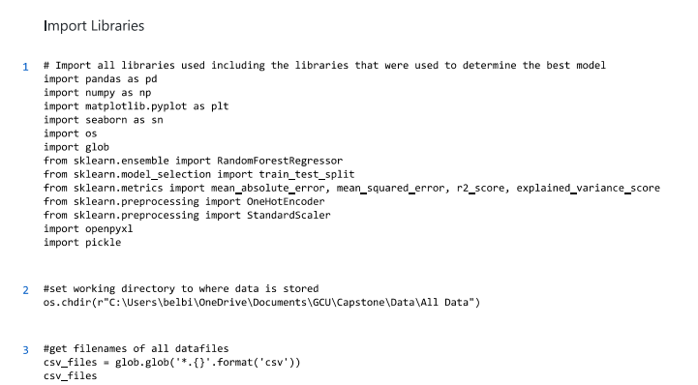

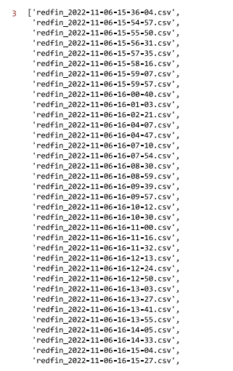

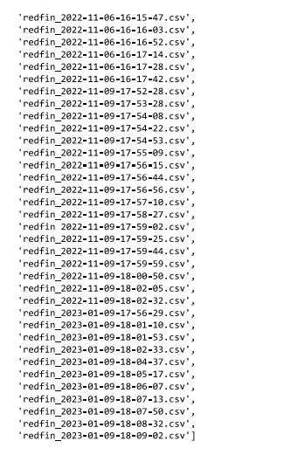 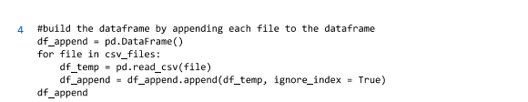

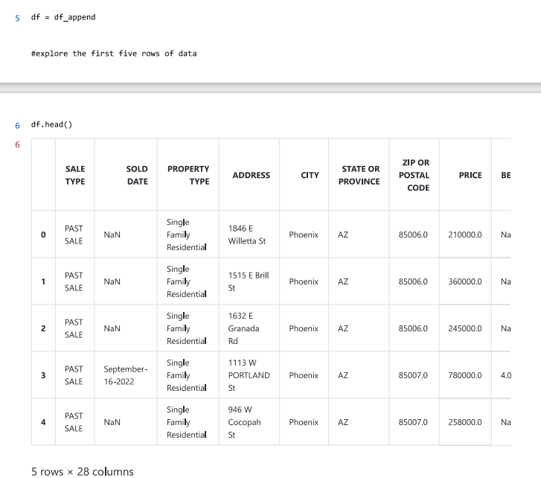

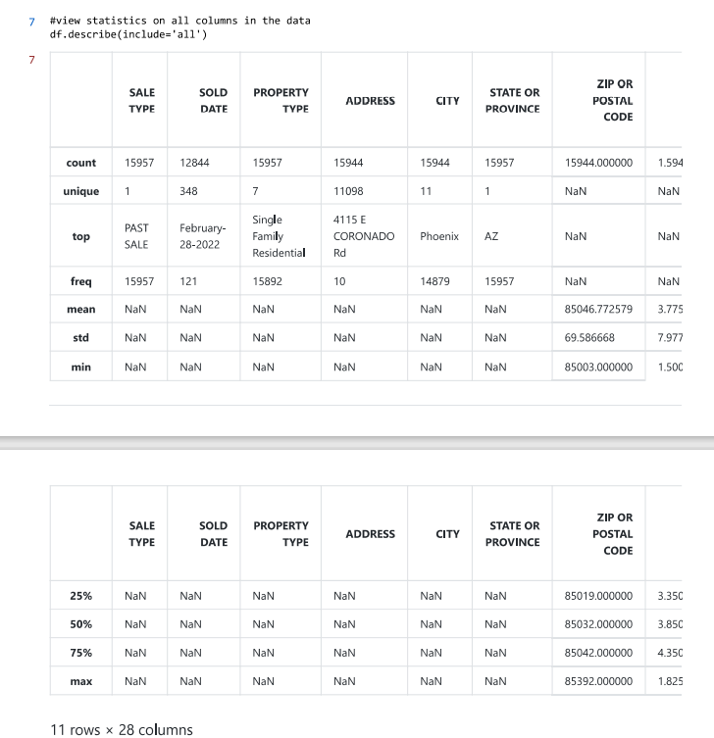

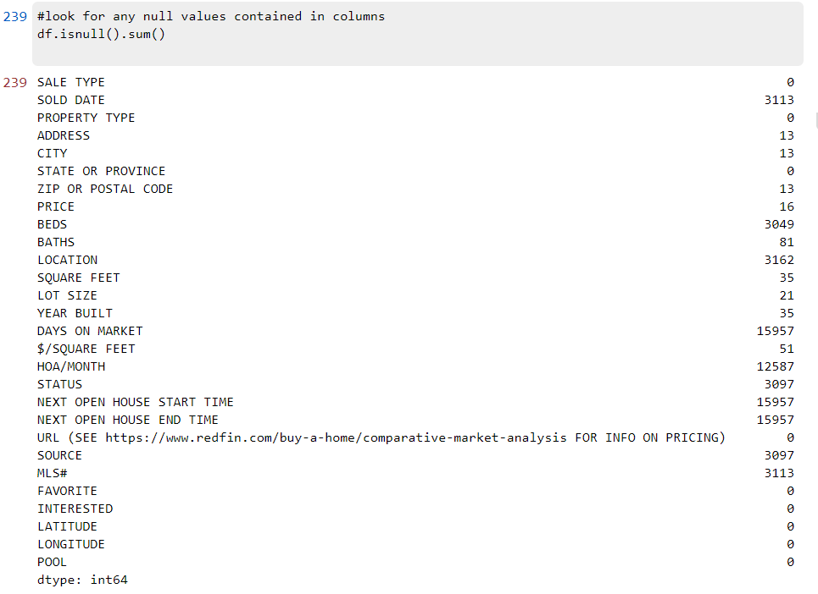

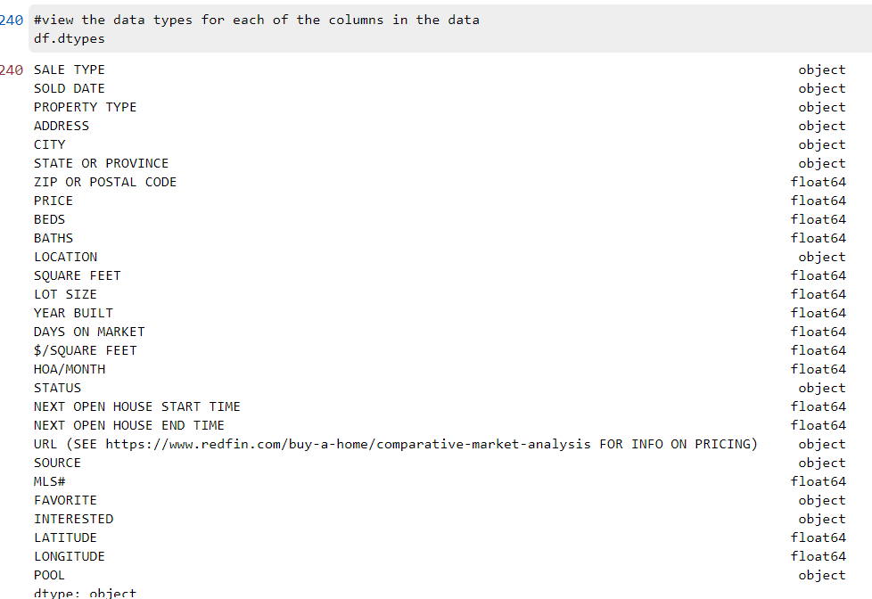

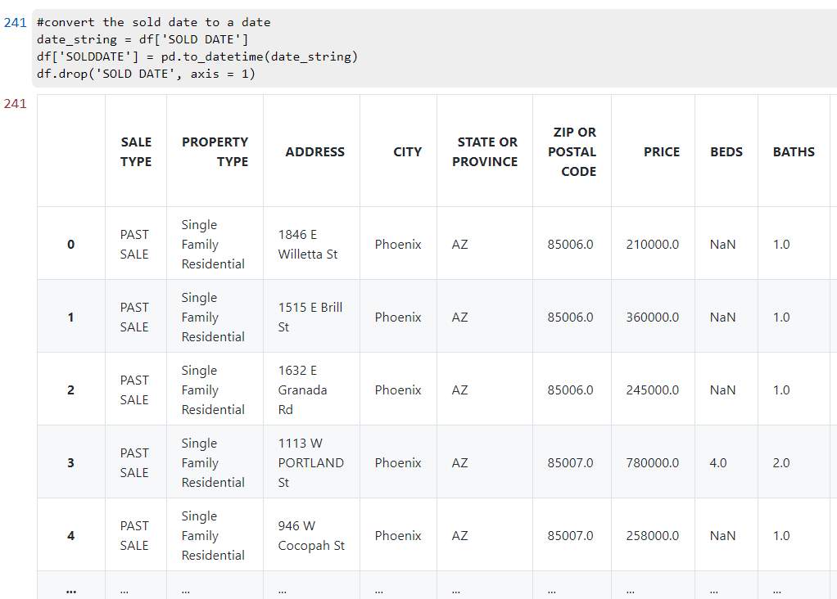

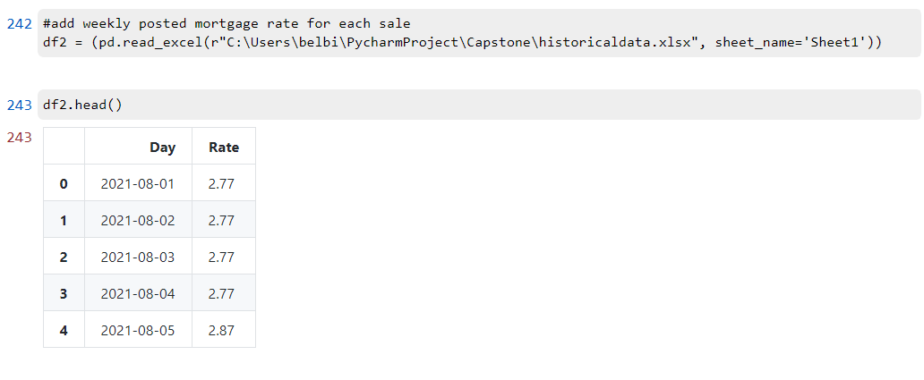

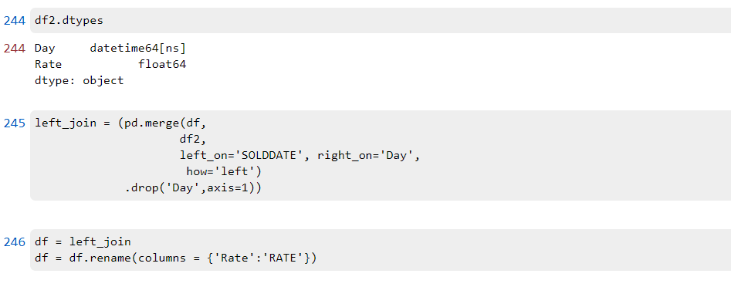

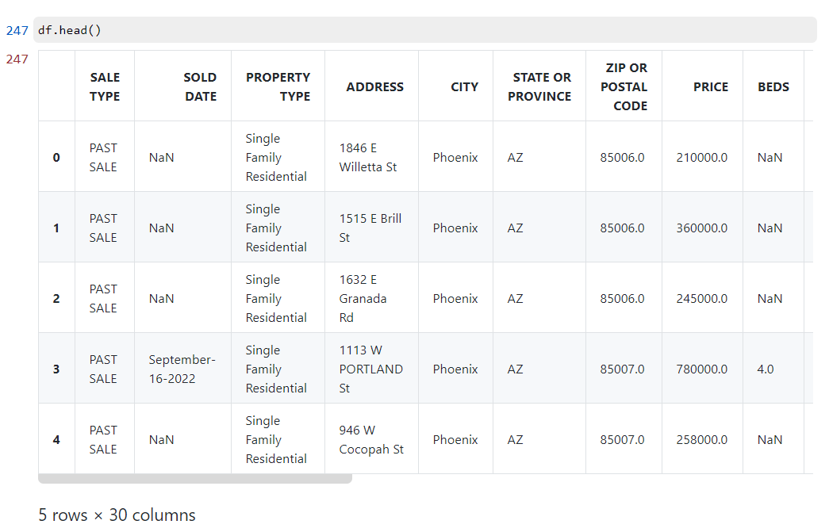

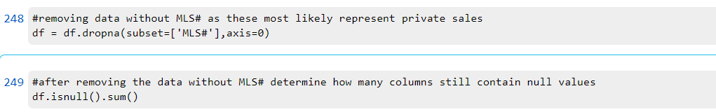

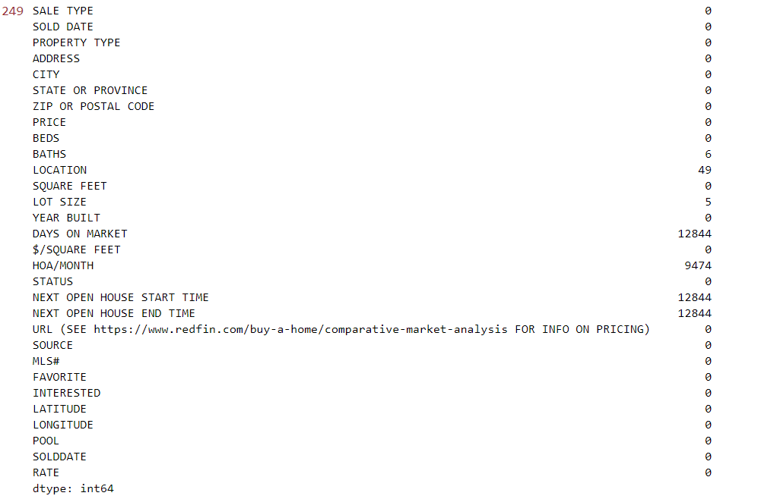

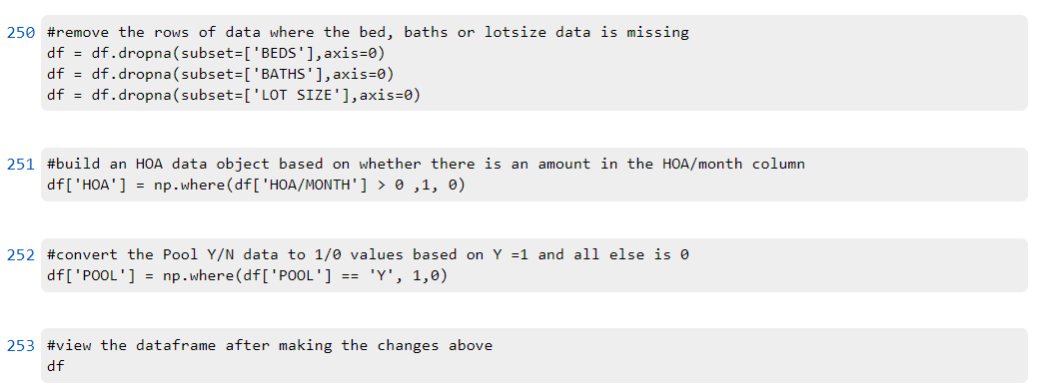

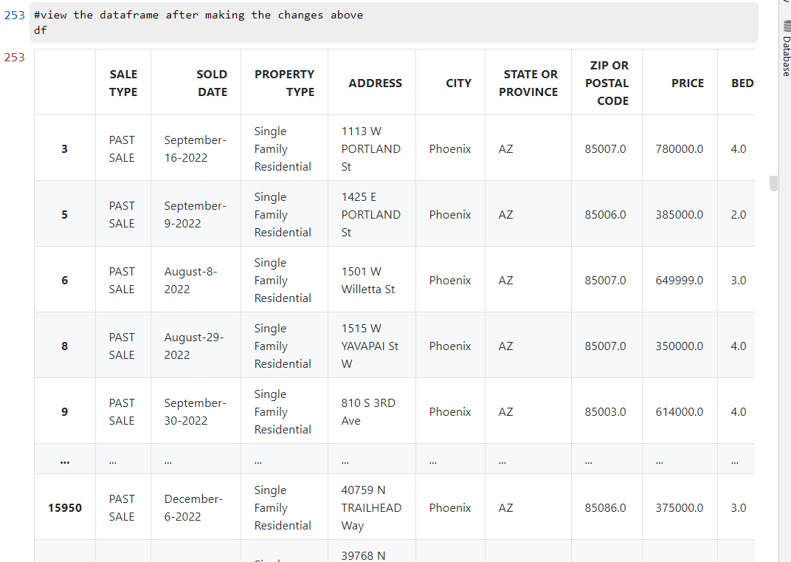

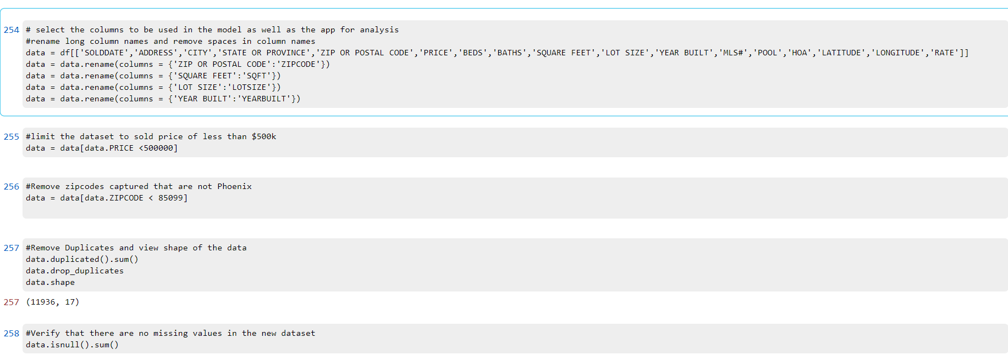

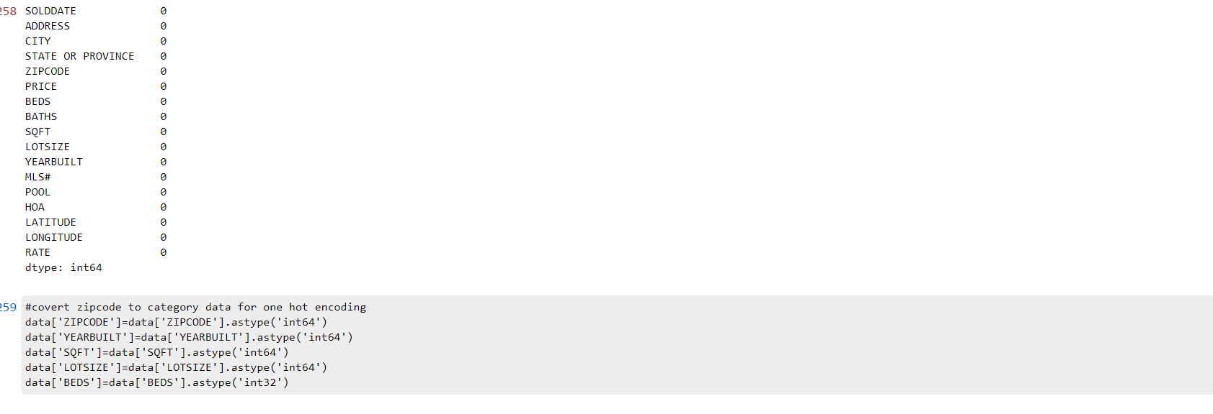

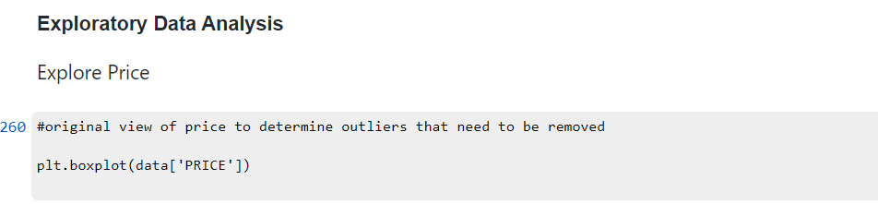

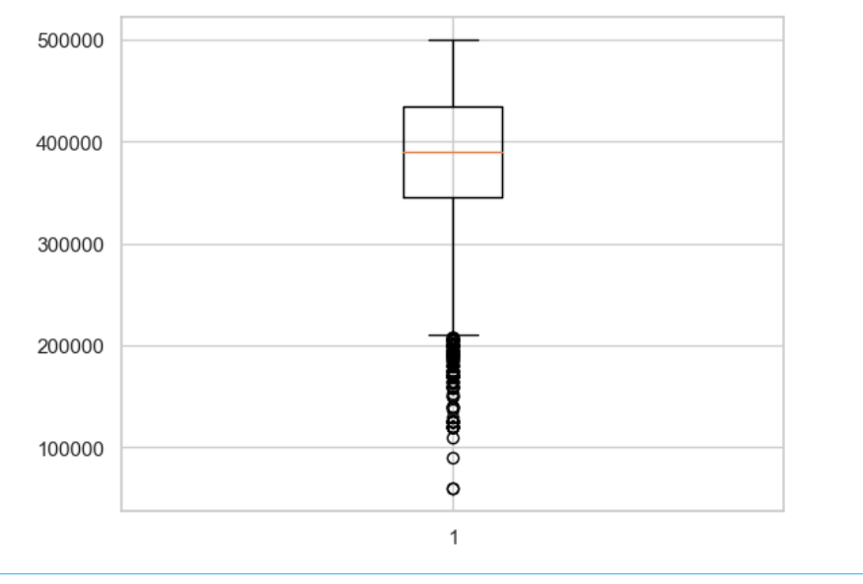

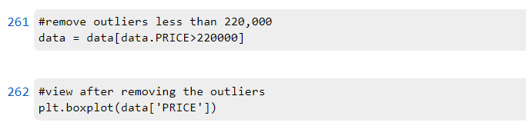

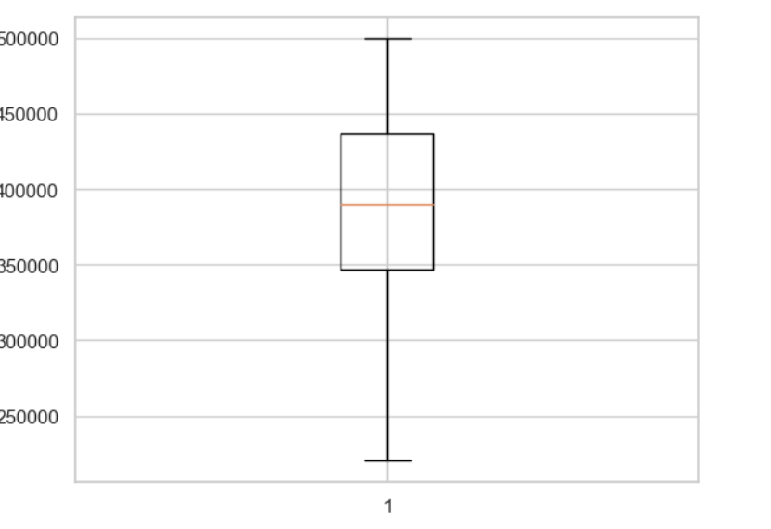

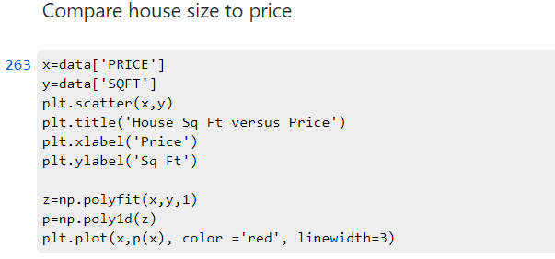

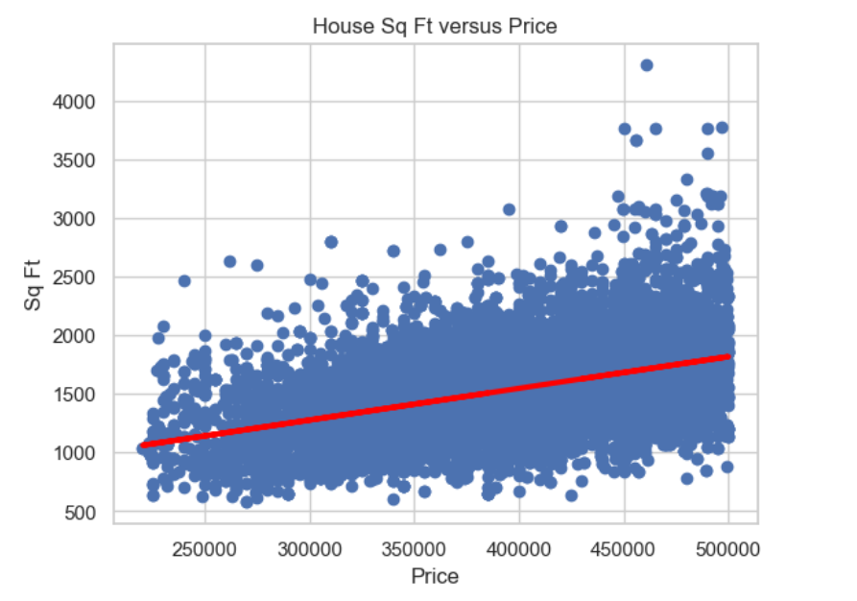

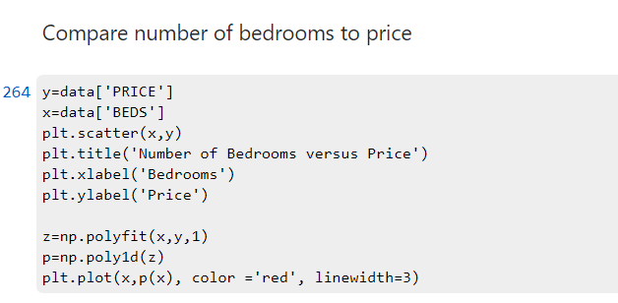

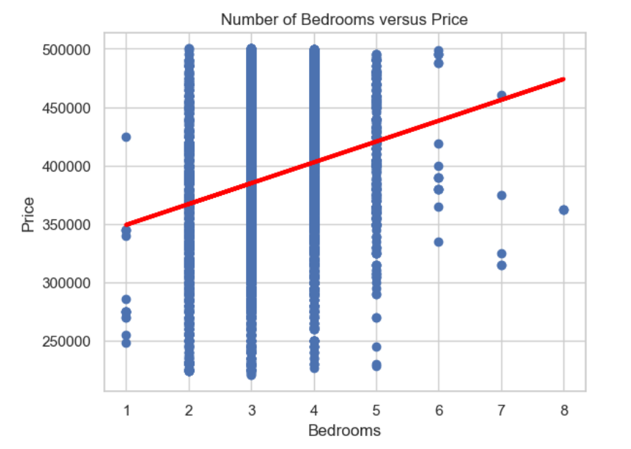

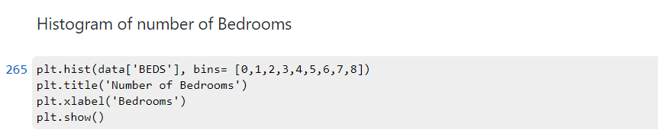

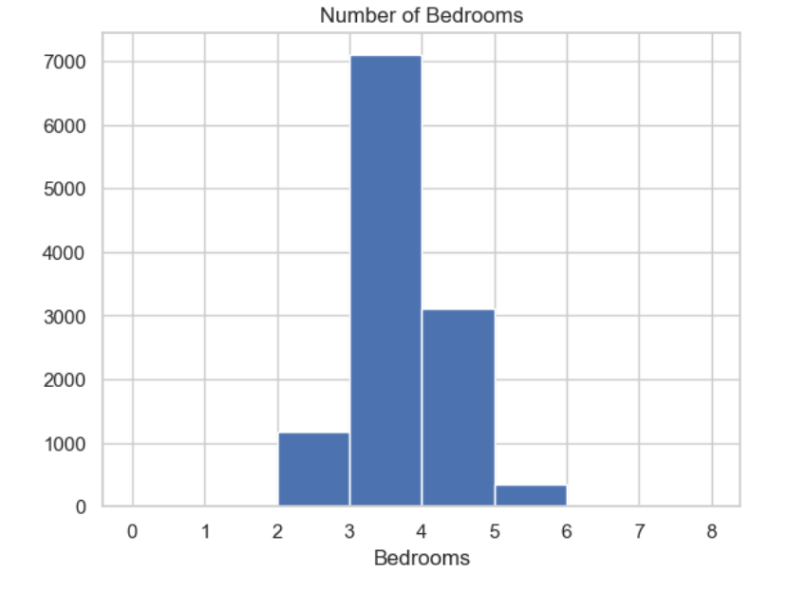



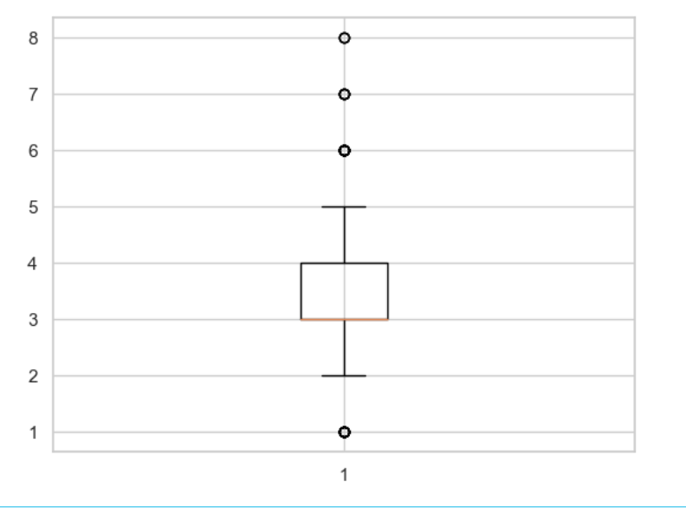

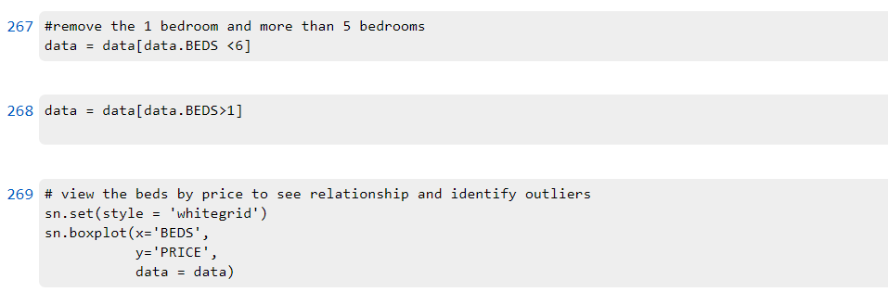

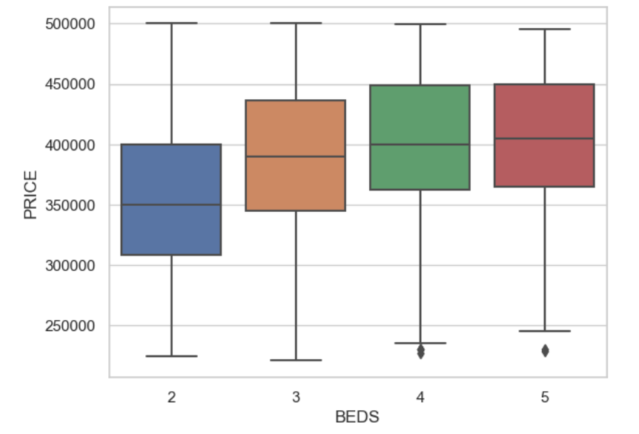

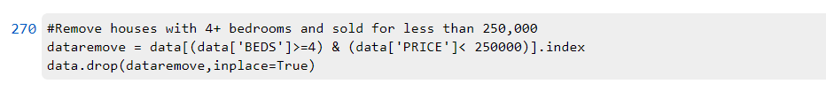

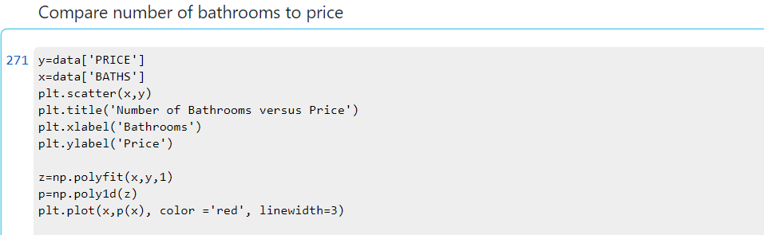

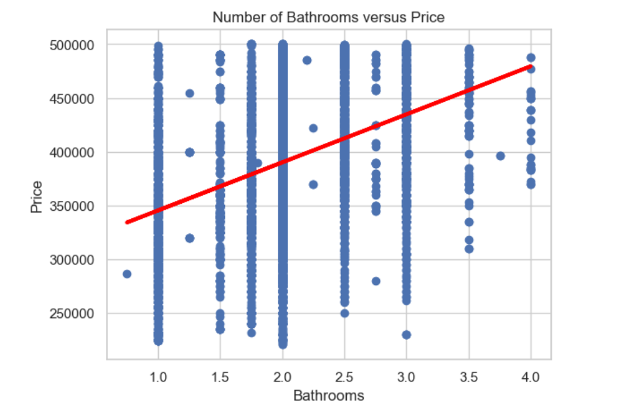

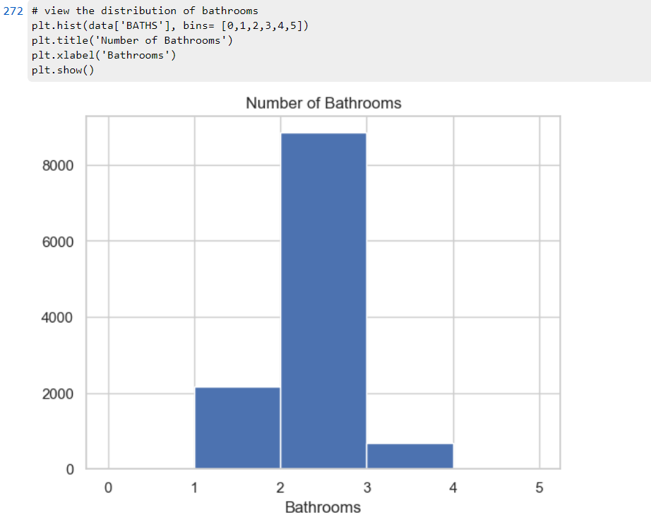



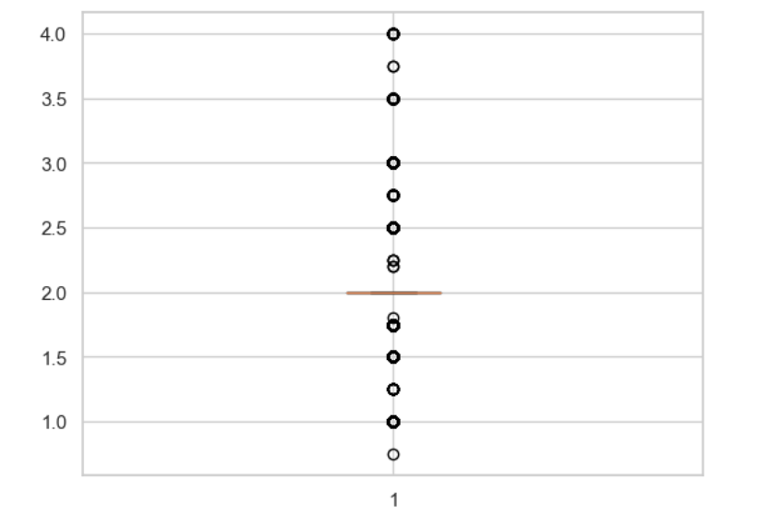



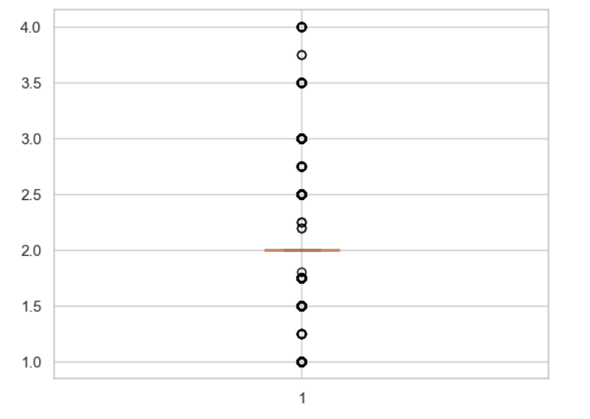

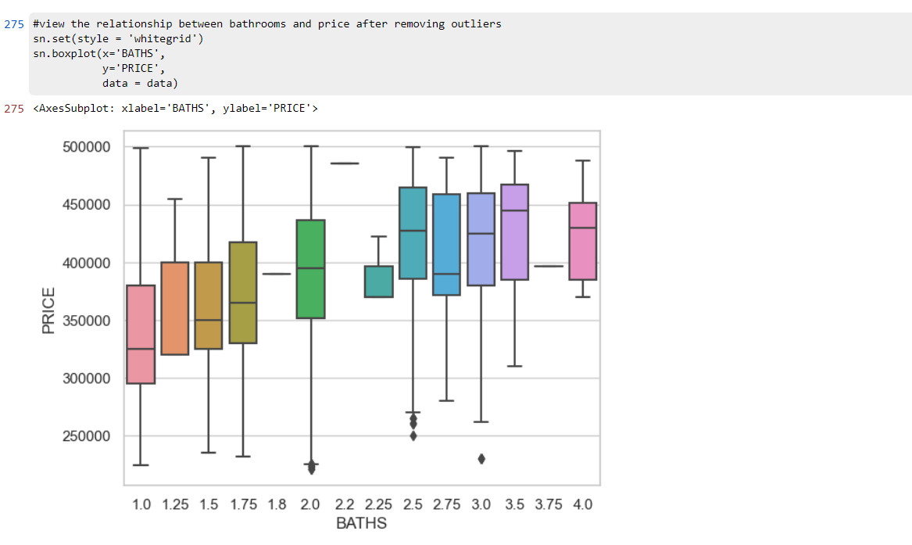

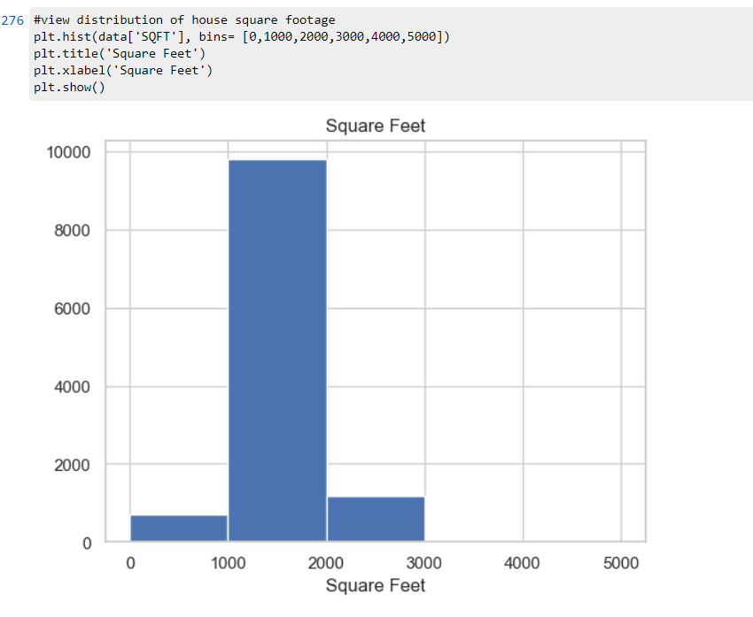

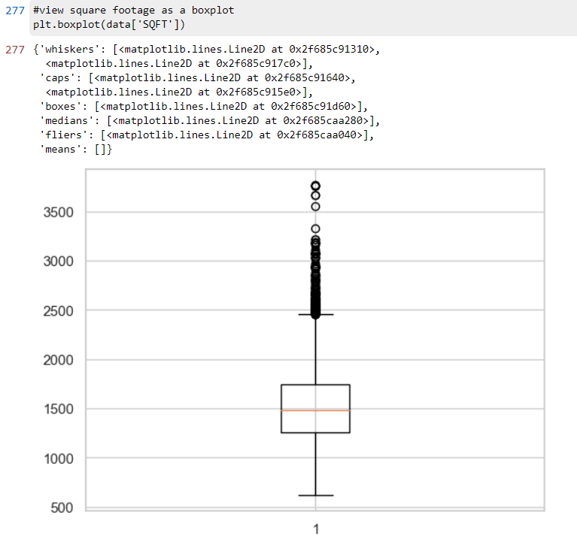

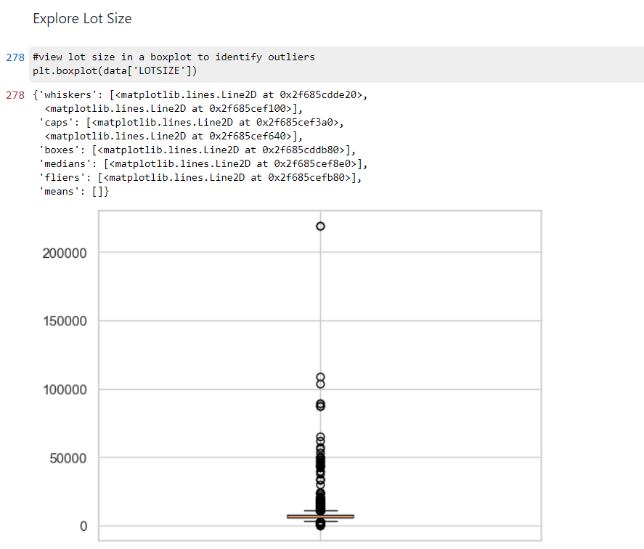

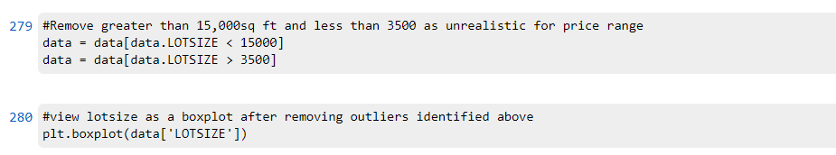

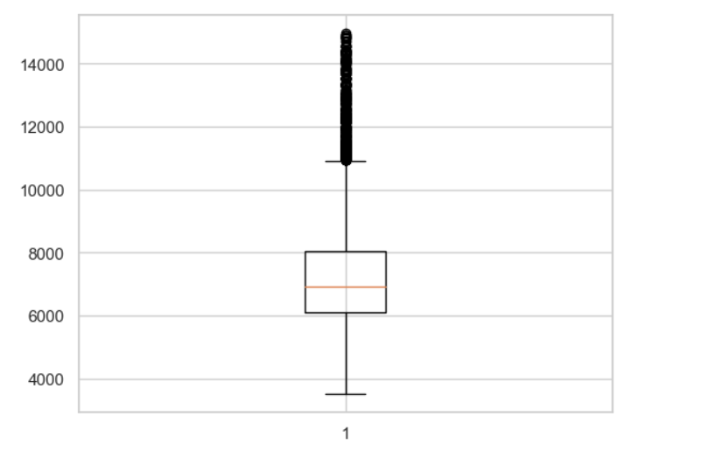

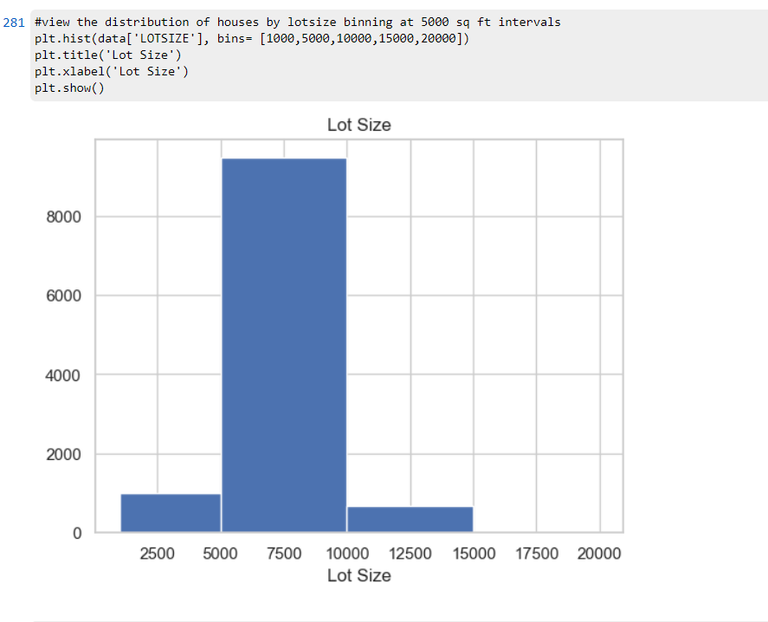 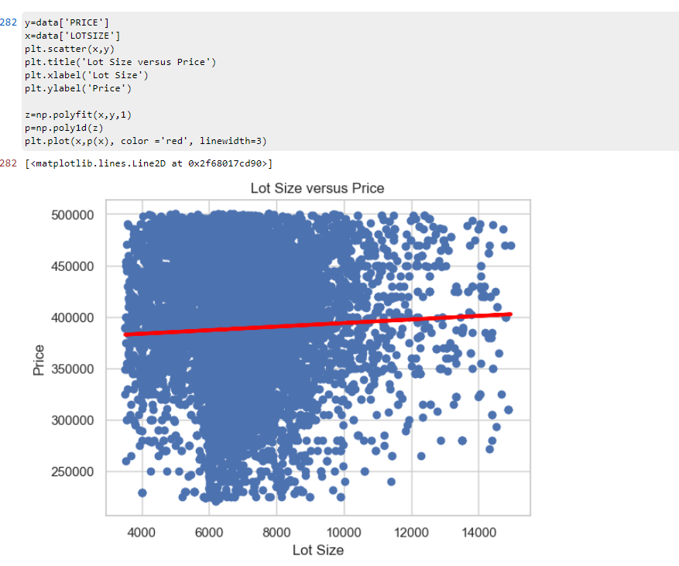

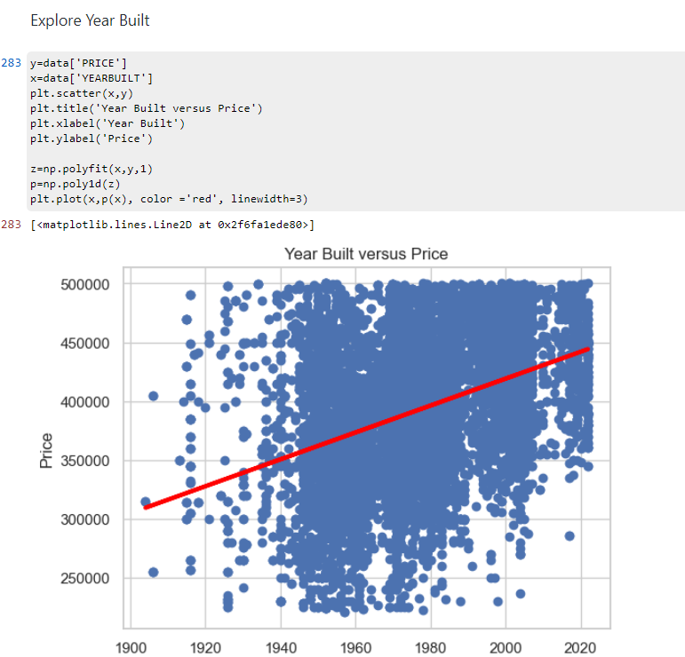

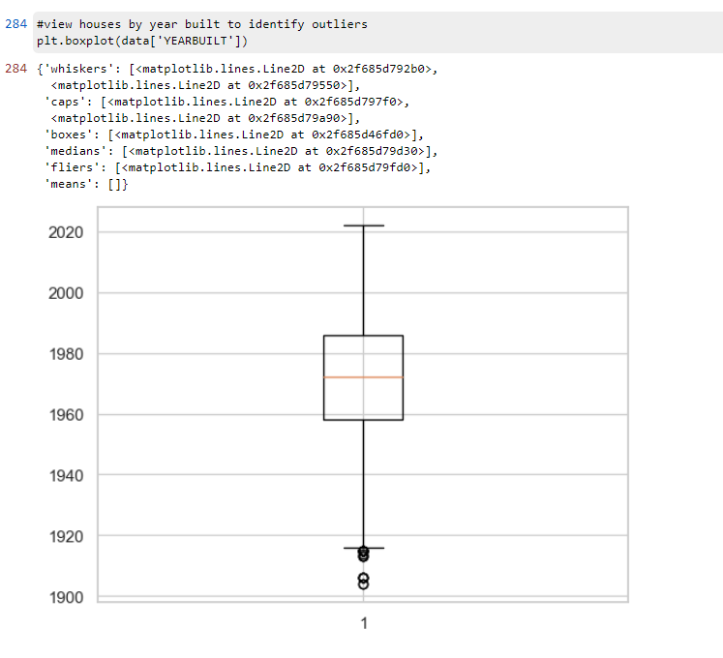

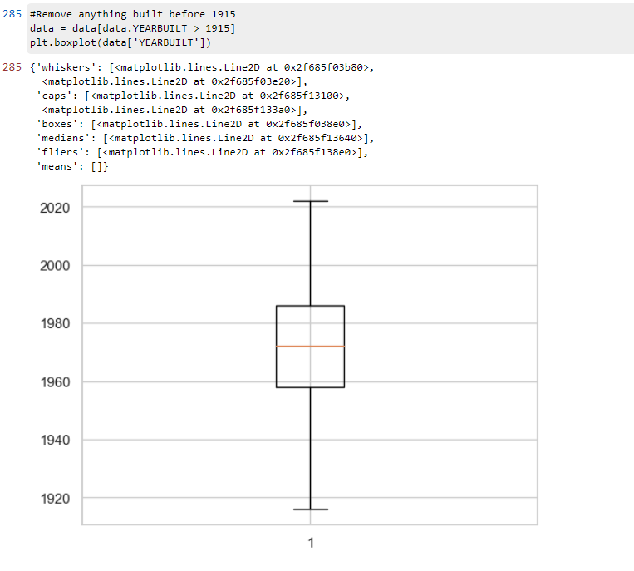

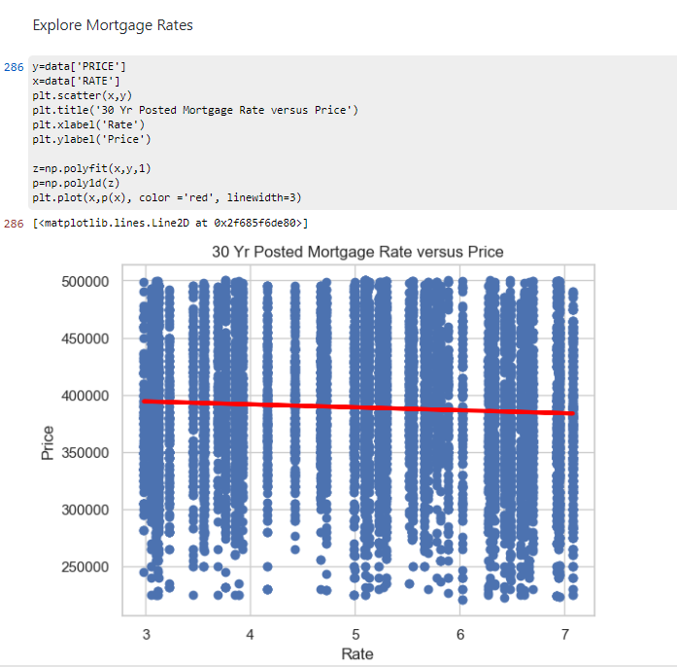

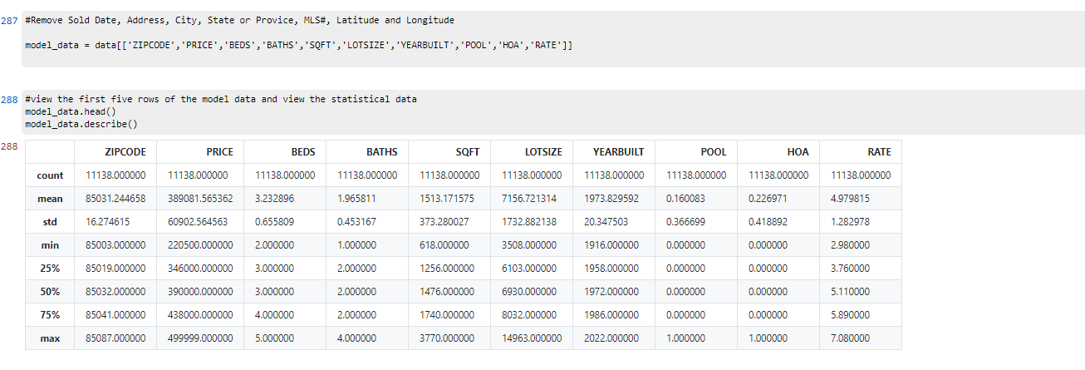

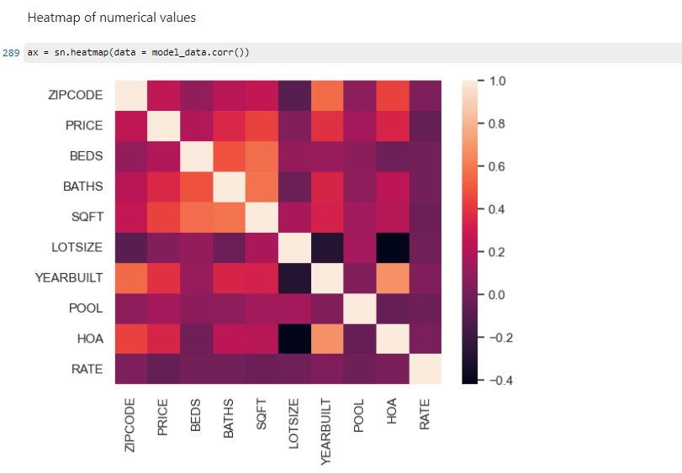

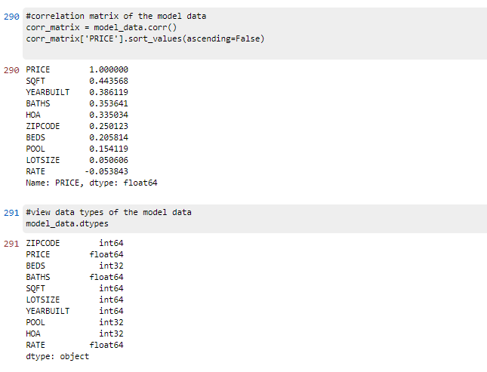

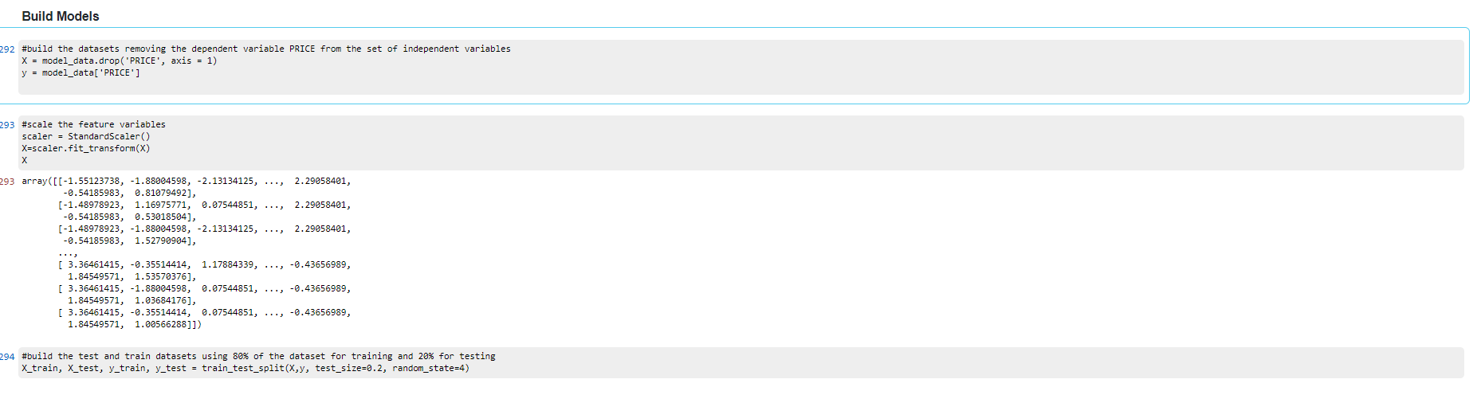

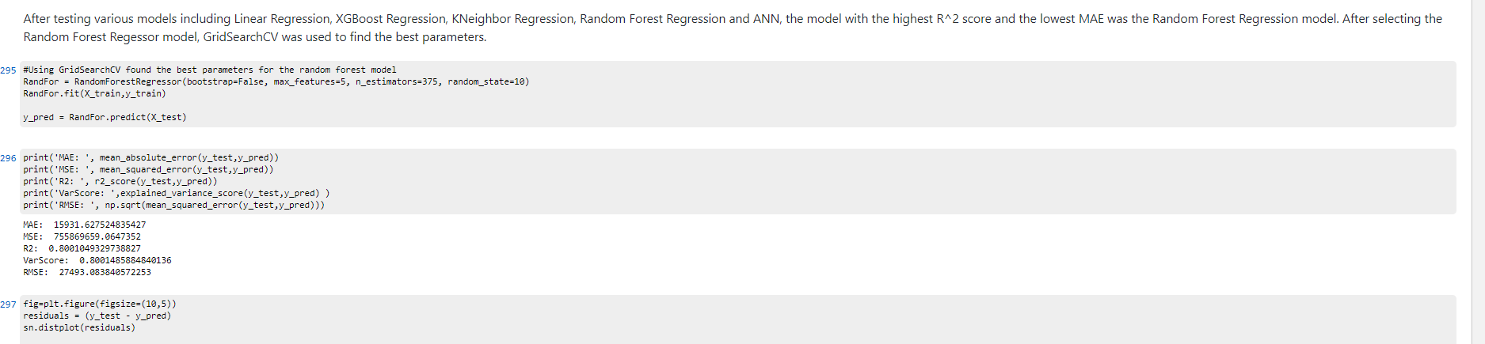

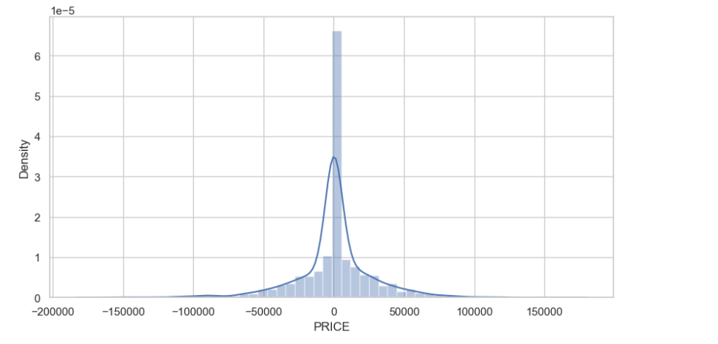

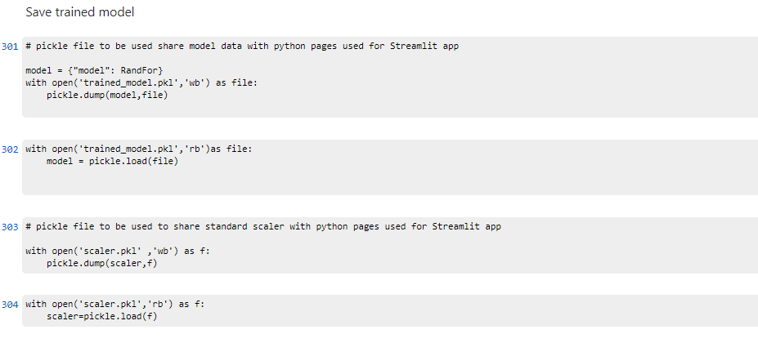

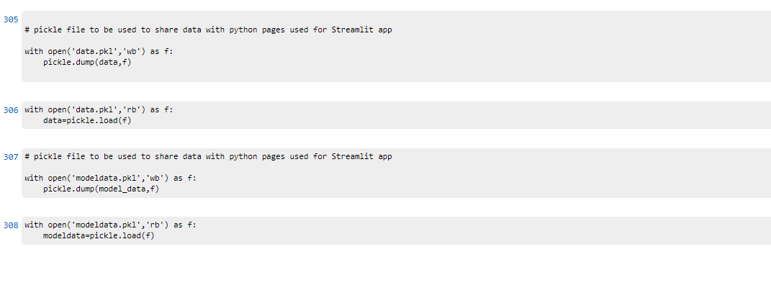

## Source Code for Building Streamlit App

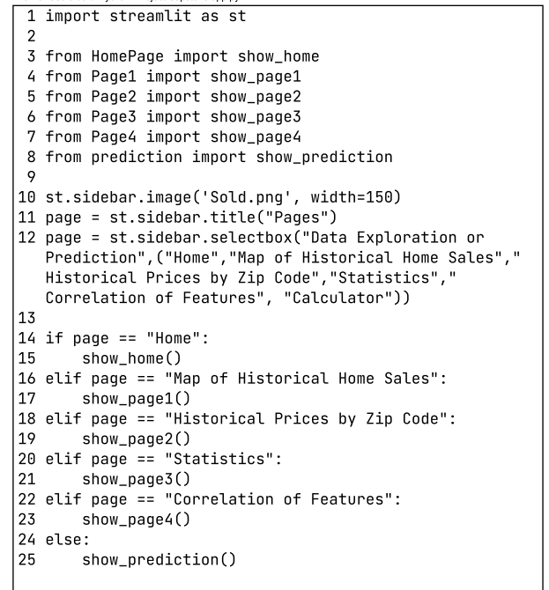

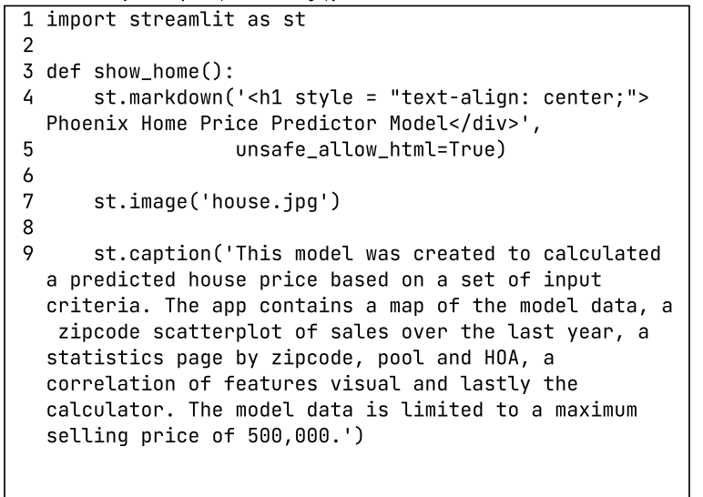

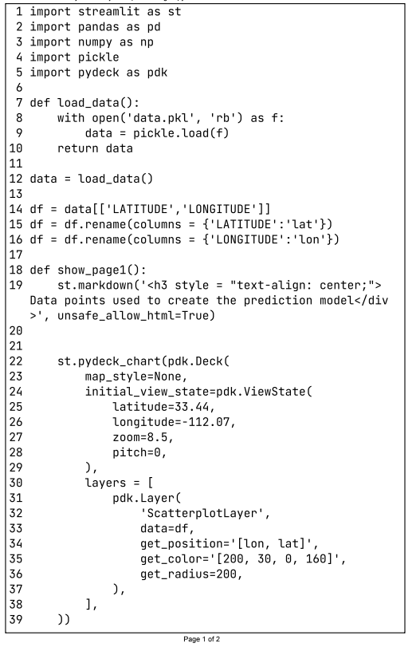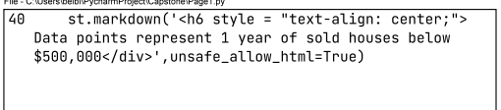

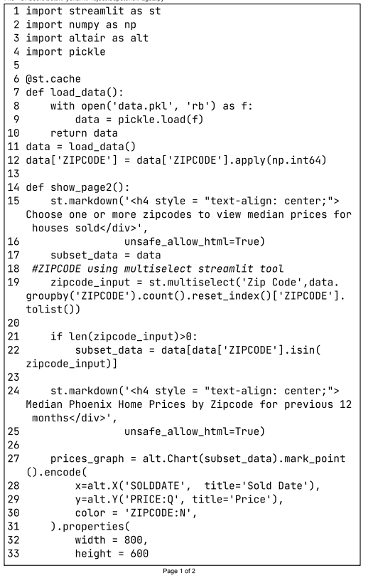

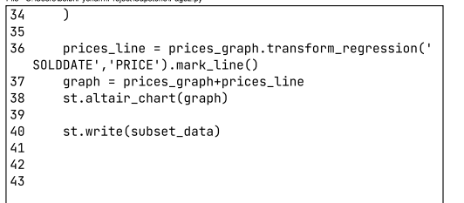

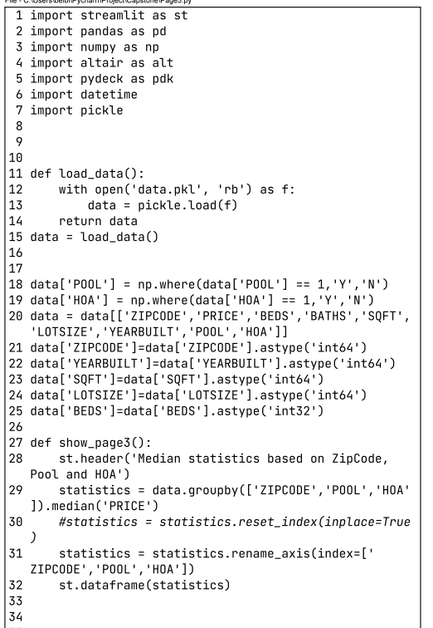

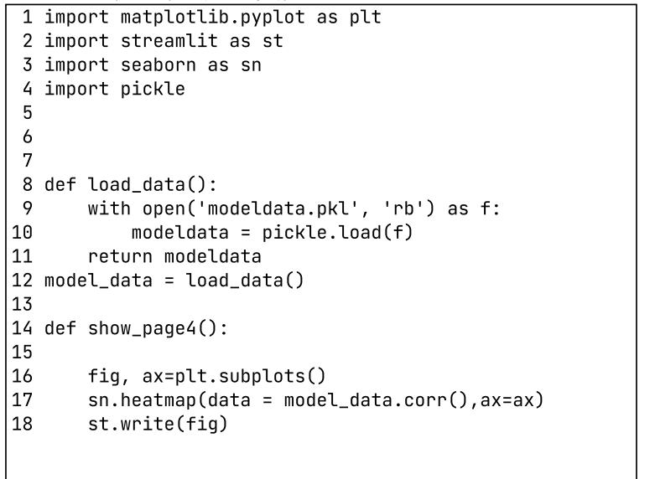

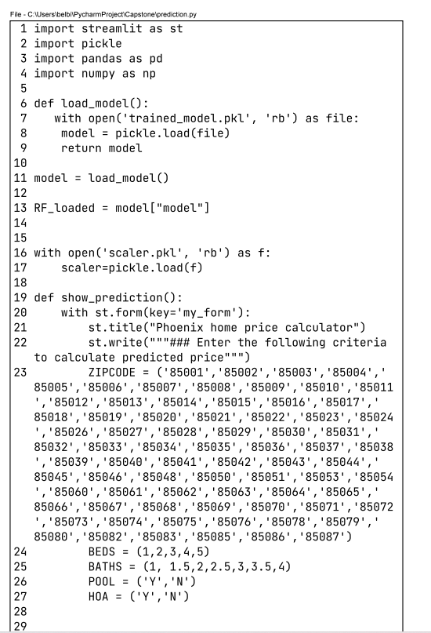

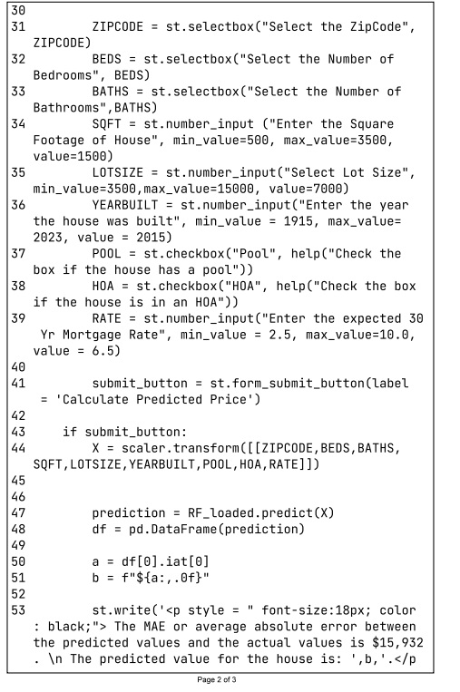

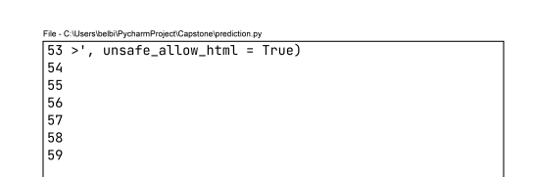

## Implementation Plan

The Phoenix home price calculator is implemented in Python using the following libraries:

* pandas
* numpy
* matplotlib
* seaborn
* os
* glob
* sklearn
  + train_test_split
  + Standard Scaler
  + RandomForestRegressor
  + metrics
* pickle
* Streamlit

Code stored and shared in

* Github
* Github desktop

Data was collected and stored as csv, to view these files Excel is also required

Model is deployed on the following cloud based service

* Streamlit cloud

The model is originally built in a Python Jupyter notebook where it was tested and validated. Once the model was completed, the model was pickled in order to be used on the python pages built to support the Streamlit app process. The OneHotEncoder, the Standard Scaler and the dataset were also picked in order to be used by the Streamlit process to convert the input values. The project is stored in GitHub and deployed on the Streamlit cloud by attaching to the GitHub repository. The data for the model has been downloaded in batches from the Redfin website versus scraping. The decision to download the data from Redfin directly is due to the blockers that Redfin has set up against scraping software. There is scraping software available that will rotate IP addresses in order to bypass some of the blockers, however the software is expensive, and the number of properties that are available by scraping is the same amount that can be manually downloaded. By selecting the manual download, the data format is consistent and easier to use. The data on Redfin was filtered by zip code and by price for the past year. If more than 350 homes were sold, the zip code would be broken down using the drawing wizard. The datafiles are combined into a single dataset using os and glob. One of the potential negative impacts that comes from the data is that the Redfin data is coming from the MLS data, which is entered by Real Estate agents, this means that there is the potential of keying errors or missing data. To account for this, the data is scrubbed and cleaned removing missing values, outliers and duplicates based on MLS listing number. Multiple visualizations were used to explore the data and identify any data issues that would impact the model outcome. The raw dataset was pared down to eight features to be used to estimate house prices, a second dataset was also built to be used to view different aspects of the data in Streamlit including latitude and longitude.

Once the Python project has saved and validated using the locally hosted Streamlit, the project and all files contained in the project directory are pushed to repository in the GitHub Desktop and eventually pushed to a new repository set up in the cloud based GitHub. The cloud based GitHub security will have to be set to public in order for the Streamlit application to be able to access the data. Once the GitHub repository is up to date, the Streamlit cloud application is connected to the repository and branch that contains the latest release of the project.

The model is built for informational purposes only using publicly available data, because of this security for the app is not a concern. To limit access to the app, Streamlit has been set to allow anyone with the shared URL to access the app online.

As with all models, the data should be refreshed on a regular basis, in this case new data should be gathered every three months and the model retrained. The user guide for this app is available in the appendix.

# Performance Analysis

## Testing

The first instance of testing was when considering the different models and choosing the model with the highest r2 value. Below are the results on the initial test prior to any tuning of the models. The model selected for the analysis was the Random Forest Regression model.

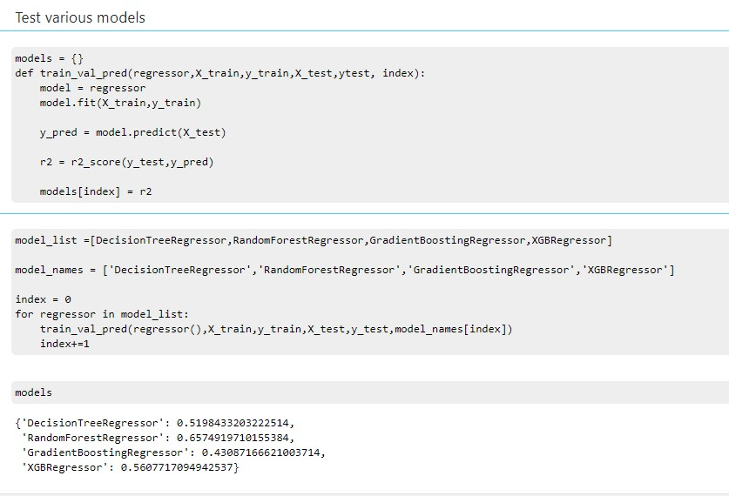

## Module Test Cases

The following test cases are for each module of the project. The first represents the initial model that is created to ensure that the results are expected. This test was completed within the Python code for the model, prior to creating the Streamlit app.

|  |  |  |  |  |  |  |  |  |  |  |  |  |  |  |
| --- | --- | --- | --- | --- | --- | --- | --- | --- | --- | --- | --- | --- | --- | --- |
|  |  |  |  |  |  |  |  |  |  |  |  |  |  |  |
| **Test Case Name:** | | Model Results Validation | | | | | | | | | | |  |  |
| **Priority:** | | High | | | | | | | | | | |  |  |
| **Module:** | | Model Predictor | | | | | | | | | | |  |  |
| **Test Detail:** | | To ensure that the expected and actual results are similar | | | | | | | | | | |  |  |
| **Test Objective:** | | Load a set of test data that contains multiple properties with different features. The set of test data should be similar to the test data for an accuracy validation. | | | | | | | | | | |  |  |
|  |  |  |  |  |  |  |  |  |  |  |  |  |  |  |
| **Test #** | **Test Details** | | | | | | | | | **Results** | | | | |
|  | ZIP CODE | BEDS | BATHS | SQFT | LOT SIZE | YR BLT | Pool | HOA | Rate | Expected Result | Actual Result | Var$ | Var % | Pass/ Fail |
| 1 | 85032 | 3 | 2 | 1500 | 10000 | 1983 | 1 | 0 | 5 | 465,000 | 467,077 | (2,077) | -0.4% | Pass |
| 2 | 85015 | 4 | 2.5 | 1800 | 6600 | 1960 | 0 | 0 | 4 | 390,000 | 405,587 | (15,587) | -4.0% | Pass |
| 3 | 85085 | 4 | 2 | 1750 | 7000 | 2009 | 1 | 1 | 6.5 | 495,000 | 483,456 | 11,544 | 2.3% | Pass |
| 4 | 85029 | 3 | 2 | 1750 | 10500 | 1970 | 1 | 0 | 4.75 | 425,000 | 421,047 | 3,953 | 0.9% | Pass |
| 5 | 85007 | 3 | 2 | 1050 | 6000 | 1954 | 0 | 0 | 6.5 | 305,000 | 323,268 | (18,268) | -6.0% | Fail |
| 6 | 85034 | 2 | 1 | 800 | 8500 | 1926 | 0 | 0 | 3.5 | 290,000 | 280,876 | 9,124 | 3.1% | Pass |
| 7 | 85017 | 3 | 2 | 1500 | 7000 | 1958 | 1 | 0 | 3 | 375,000 | 335,836 | 39,164 | 10.4% | Fail |
| 8 | 85050 | 4 | 2.5 | 2200 | 4500 | 1999 | 0 | 1 | 5 | 490,000 | 488,690 | 1,310 | 0.3% | Pass |
| 9 | 85086 | 3 | 2 | 1900 | 6600 | 2000 | 1 | 1 | 6 | 475,000 | 471,547 | 3,453 | 0.7% | Pass |
| 10 | 85043 | 5 | 3 | 2600 | 6300 | 2004 | 1 | 1 | 6 | 450,000 | 448,136 | 1,864 | 0.4% | Pass |

The determination of passing or failing the test is dependent on if the variance in dollars is less than the MAE of $15,932. There are two properties that failed this test, however there are other factors that also influence the price of the house that are not included in the model due to lack of data. This includes any updates done which will have a greater impact on older home values as well as decorating or layout that are hard to measure with quantitative data. The other eight properties in the test sample had actual values close to expected resulting in a pass. Overall this test passed.

The next set of test cases covers each of the pages of the Streamlit app to ensure that the app is functioning as expected. The first page after the home page is a visual representation of the area covered by the model. The map is of the Phoenix metro area and can be moved and zoomed in to show where the house sales represented in the model are located.

|  |  |  |  |  |  |  |  |  |  |  |  |  |  |  |
| --- | --- | --- | --- | --- | --- | --- | --- | --- | --- | --- | --- | --- | --- | --- |
|  |  |  |  |  |  |  |  |  |  |  |  |  |  |  |
|  | **Test Case Name:** | | Map of Historical Home Sales | | | | | | | | | | |  |
|  | **Priority:** | | Low | | | | | | | | | | |  |
|  | **Module:** | | Map of Historical Home Sales | | | | | | | | | | |  |
|  | **Test Detail:** | | Viewability of the map | | | | | | | | | | |  |
|  | **Test Objective:** | | To be able to view the map and see the area represented by the model data | | | | | | | | | | |  |
|  |  |  |  |  |  |  |  |  |  |  |  |  |  |  |
|  |  |  |  |  |  |  |  |  |  |  |  |  |  |  |
|  | **Test #** | **Test Details** | | | | | | | | **Results** | | | **Pass/Fail** |  |
|  | 1 | Ability to see the entire map when clicking on the Streamlit app page | | | | | | | | Able to open the page and see the dots of properties used in the model | | | Pass |  |
|  | 2 | Ability to zoom in and out on the map to see specific areas within Phoenix | | | | | | | | Able to zoom in and out on the map and move the map around | | | Pass |  |

The second page of the Streamlit app is a scatterplot of each house by zip code as well as a corresponding trend line. The options on this page include viewing all zip codes, a singular zip code or multiple zip codes where each zip code is a distinct color. The data table under the scatterplot chart shows the details on each of the properties represented by a colored circle on the chart.

|  |  |  |  |  |  |  |  |  |  |  |  |  |
| --- | --- | --- | --- | --- | --- | --- | --- | --- | --- | --- | --- | --- |
| **Test Case Name:** | | Historical Prices | | | | | | | | | | |
| **Priority:** | | Medium | | | | | | | | | | |
| **Module:** | | Historical Prices by Zip Code | | | | | | | | | | |
| **Test Detail:** | | Select different zip codes either single or multiples and view the trend results | | | | | | | | | | |
| **Test Objective:** | | Ability to navigate to multiple zip codes to see historical price trends | | | | | | | | | | |
|  |  |  |  |  |  |  |  |  |  |  |  | | |  |
|  |  |  |  |  |  |  |  |  |  |  |  | | |  |
| **Test #** | **Test Details** | | | | | **Results** | | | | | | **Pass/Fail** |
| 1 | select a single zip code 85017 and view the trend of sales | | | | | Zip code 85017 shows the linear trend of prices as well as single color dots representing each home sale. | | | | | | Pass |
| 2 | able to clear the zip codes from the search bar | | | | | able to remove the zip code and bring the options back to original | | | | | | Pass |
| 3 | select multiple zip codes 85085, 85050, 85086 and view the resulting trend | | | | | Each zip code is represented by a separate color | | | | | | Pass |
| 4 | the data table under the scatterplot reflects the zip codes showing in the chart above. | | | | | the data table changes as the zip codes in the scatterplot change | | | | | | Pass |

The third page of the app is a data table that shows the median statistics by zip code and whether there is a pool or an HOA on the property.

|  |  |  |  |  |  |  |  |  |  |  |  |  |
| --- | --- | --- | --- | --- | --- | --- | --- | --- | --- | --- | --- | --- |
|  |  |  |  |  |  |  |  |  |  |  |  |  |
| **Test Case Name:** | | Statistics of Home Sales | | | | | | | | | | |
| **Priority:** | | Low | | | | | | | | | | |
| **Module:** | | Statistics of Home Sales | | | | | | | | | | |
| **Test Detail:** | | View the median statistics of home sales | | | | | | | | | | |
| **Test Objective:** | | Ability to scroll and view the median price, beds, baths, square footage, lot size, year built and mortgage rate by zip code, pool, and HOA | | | | | | | | | | |
|  |  |  |  |  |  |  |  |  |  |  |  |  |
|  |  |  |  |  |  |  |  |  |  |  |  |  |
| **Test #** | **Test Details** | | | | | | | | **Results** | | | **Pass/Fail** |
| 1 | scroll and view each of the zip codes with property sales between 85001 and 85087 | | | | | | | | The first zip code with data is 85003 and able to scroll and see statistics through all zip codes ending with 85087 | | | Pass |

The fourth page contains the correlation of home features. This is a static view that does not change but represents the data that was used to create the model.

|  |  |  |  |  |  |  |  |  |  |  |  |  |  |
| --- | --- | --- | --- | --- | --- | --- | --- | --- | --- | --- | --- | --- | --- |
| **Test Case Name:** | | Correlation of Home Features | | | | | | | | | | | |
| **Priority:** | | Low | | | | | | | | | | | |
| **Module:** | | Correlation of Home Features | | | | | | | | | | | |
| **Test Detail:** | | Able to see the correlation between house features both positive and negative. | | | | | | | | | | | |
| **Test Objective:** | | View the correlation of features | | | | | | | | | | | |
|  |  |  |  |  |  |  |  |  |  |  |  | |  | |
|  |  |  |  |  |  |  |  |  |  |  |  | |  | |
| **Test #** | **Test Details** | | | | | | | | **Results** | | | **Pass/Fail** | |
| 1 | Using the color reference guide on the side, view a negative correlation for expected values | | | | | | | | The correlation between rate and price is negative meaning that as the rate increases the price decreases. This is as expected | | | Pass | |
| 2 | Using the color reference guide on the side, view a positive correlation for expected values | | | | | | | | The correlation between square footage and number of bathrooms is positive meaning that as the number of bathrooms goes up so does the square footage as expected | | | Pass | |

The final page of the app contains the house price calculator which predicts the value of the house based on the input features entered by the user. This calculator should provide the same results as the original test.

|  |  |  |  |  |  |  |  |  |  |  |  |  |
| --- | --- | --- | --- | --- | --- | --- | --- | --- | --- | --- | --- | --- |
| **Test Case Name:** | | Home Price Calculator | | | | | | | | | | |
| **Priority:** | | High | | | | | | | | | | |
| **Module:** | | Phoenix Home Price Calculator | | | | | | | | | | |
| **Test Detail:** | | Results should be the same as the original test data in Test Case: Model Results Validation | | | | | | | | | | |
| **Test Objective:** | | To confirm that the calculator contained in the app provides the same results as the original python model | | | | | | | | | | |
|  |  |  |  |  |  |  |  |  |  |  |  | | |  |
|  |  |  |  |  |  |  |  |  |  |  |  | | |  |
| **Test #** | **Test Details** | | | | | | | | **Results** | | | **Pass/Fail** |
| 1 | See feature details in test #1 in Model Results Validation | | | | | | | | 467,077 | | | Pass |
| 2 | See feature details in test #2 in Model Results Validation | | | | | | | | 405,587 | | | Pass |
| 3 | See feature details in test #3 in Model Results Validation | | | | | | | | 483,456 | | | Pass |
| 4 | See feature details in test #4 in Model Results Validation | | | | | | | | 421,048 | | | Pass |
| 5 | See feature details in test #5 in Model Results Validation | | | | | | | | 323,268 | | | Pass |
| 6 | See feature details in test #6 in Model Results Validation | | | | | | | | 280,877 | | | Pass |
| 7 | See feature details in test #7 in Model Results Validation | | | | | | | | 335,836 | | | Pass |
| 8 | See feature details in test #8 in Model Results Validation | | | | | | | | 488,690 | | | Pass |
| 9 | See feature details in test #9 in Model Results Validation | | | | | | | | 471,547 | | | Pass |
| 10 | See feature details in test #10 in Model Results Validation | | | | | | | | 448,136 | | | Pass |

## Requirements Testing

The following are the functional requirements of the capstone project, and each represents a component of the performance verification.

* The system will allow users to explore multiple visualizations of the houses sold in Phoenix over the last year.
* The system will allow users to see statistics on home sales such as median house price per zip code or number of bedrooms.
* The system will allow users to enter input data to predict what the price of the house will be to give investors ideas of what areas

Many areas of the requirements testing were also covered in the module testing above. The additional testing is to provide assurance that the original requirements of the project have been met.

|  |  |  |
| --- | --- | --- |
| **Component:** | | Ability to explore multiple visualizations of houses sold in Phoenix |
| **Name of Developer:** | | Dawn Belbin |
| **Name of Reviewer:** | | Dawn Belbin |
|  |  |  |
|  |  |  |
| **Type** | **Pass** | **Comments** |
| Functionality | Pass | Able to click through multiple tabs showing map covered by model, zip code specific sales by date |
| Performance | Pass | Streamlit did not lag and was able to perform and render the images without any issues. |

|  |  |  |
| --- | --- | --- |
| **Component:** | | Ability to see statistics on home sales |
| **Name of Developer:** | | Dawn Belbin |
| **Name of Reviewer:** | | Dawn Belbin |
|  |  |  |
|  |  |  |
| **Type** | **Pass** | **Comments** |
| Functionality | Pass | Multiple tabs for statistical data including median historical values by zip code, pool, and HOA as well as correlation heatmap of the house features |
| Performance | Pass | Performance was quick as both tabs are static table/heatmap |

|  |  |  |
| --- | --- | --- |
| **Component:** | | Input data and predict house price |
| **Name of Developer:** | | Dawn Belbin |
| **Name of Reviewer:** | | Dawn Belbin |
|  |  |  |
|  |  |  |
| **Type** | **Pass** | **Comments** |
| Functionality | Pass | The calculator tab was able to take the inputs and predict a price. There are min and max values or drop down values for all input fields to reduce the risk of inputting bad data |
| Performance | Pass | The performance on the model was quick and returned a prediction within 1-2 seconds. |

## System Testing

The system testing and end to end testing was performed with both the component testing as well as the module testing to ensure that each page within the app loads and renders appropriately and that the model calculates a prediction based on the inputs given.

## Operation and Maintenance

The operation and maintenance section of the project covers the user guide to assist with end users using the model and app as well as the maintenance and updating step to keep the model accurate or to scale the model to cover more homes.

# User Guide

The Phoenix home price predictor is a model that is available to the casual investor to understand how real estate prices are affected by different features including zip code, pool, HOA, number of bedrooms, number of bathrooms, square footage of the house, lot square footage, and the year the house was built. The data used only includes those homes sold over the last year for $500,000 or less.

This users guide will walk through each of the screens of the app and explain the features and how to interact with the app.

The app can be found at the following url: <https://dbelbin-capstone-app-mp6x0y.streamlit.app/>

## Home Page

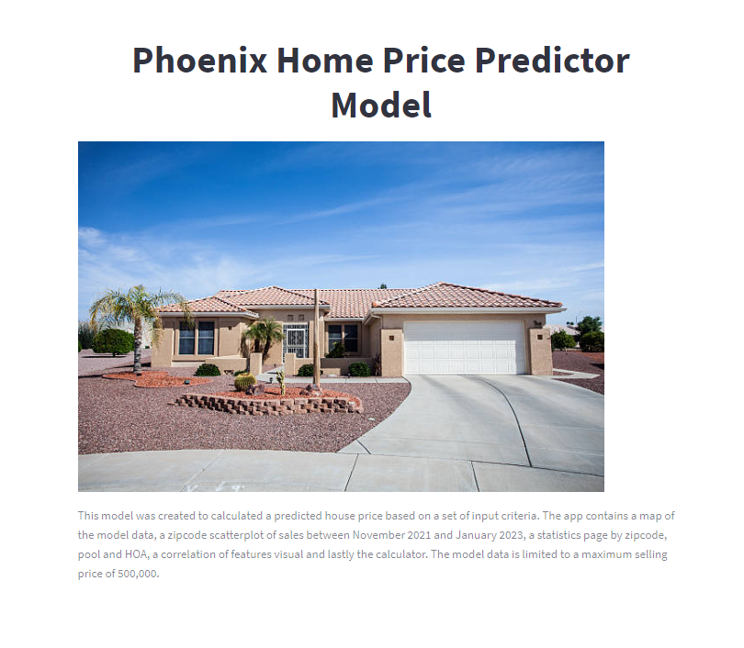

The first view of the app will display as shown above. This home page is the entrance into the app and navigating through the app will be down through the sidebar under the sold image



Under the Pages header, there is a sub header showing Data Exploration or Prediction, within this header is a drop down selector to choose which page to navigate to. The options are shown below. These options are available from any of the pages.

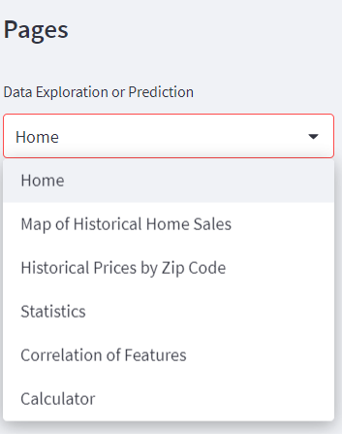

## Map of Historical Home Sales

The map of historical home sales is an informational page to understand which area is covered by this app. Each red dot represents a house sold under $500,000 in the last year. The model is only applicable to zip codes within the City of Phoenix and does not cover any suburbs. This map has the user the option to zoom in and scroll around the map to highlight specific areas.

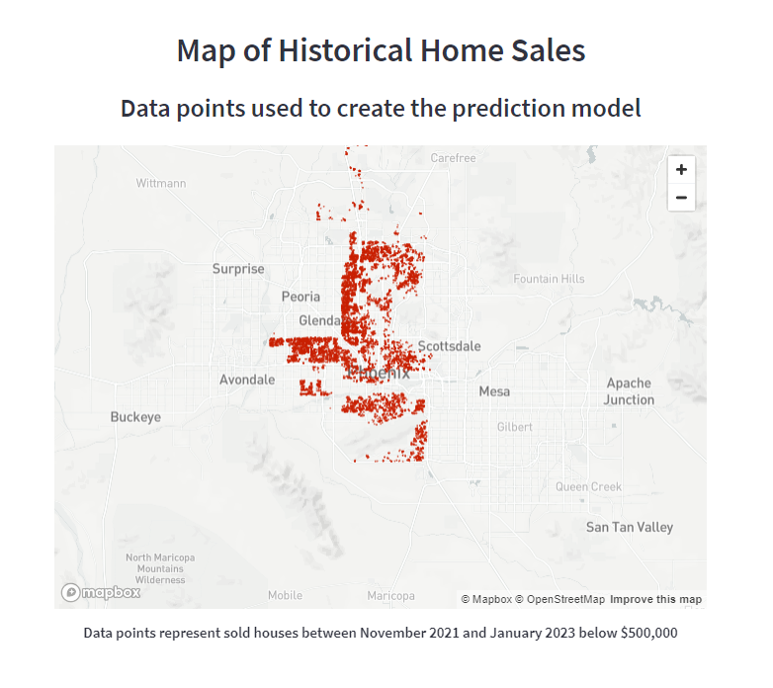

## Historical Prices by Zip Code

When navigating to this page, the filter is set to include all zip codes and home sales on the graph as shown below.

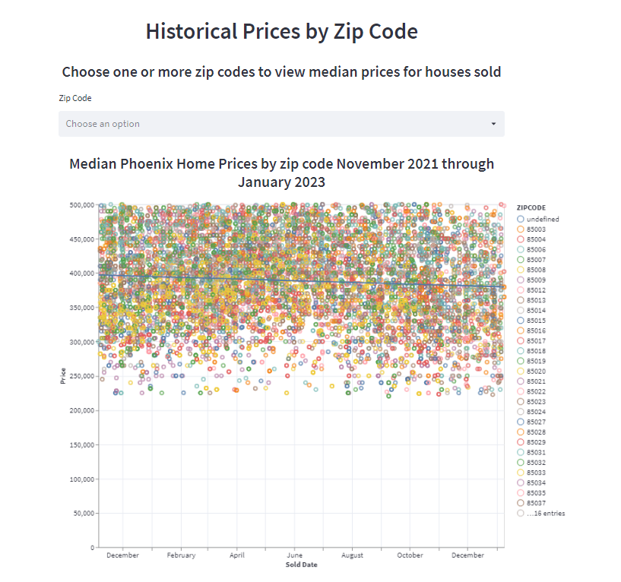

The first step is to use the drop down selector and choose one or more zip codes to view their prices over the past year. Within the chart is a trend line to show how the prices have trended over the prior year.

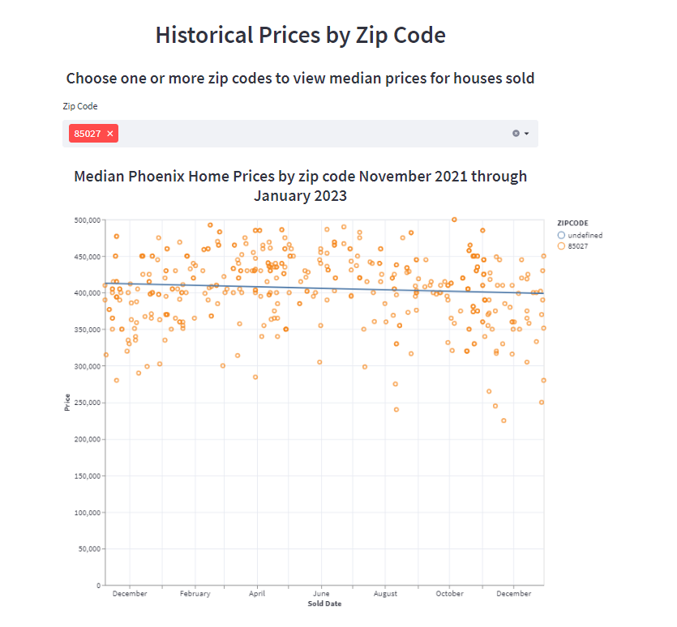

When selecting, the data table at the bottom will reflect the properties shown on the scatterplot above. The data table can be viewed by scrolling down through all the properties or right to see the different features.

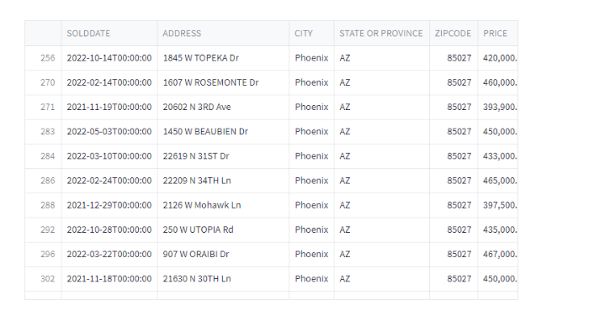

## Statistics by Home Sales

The statistics by Home Sales page provides the median price, median number of bedrooms, median number of bathrooms, median square footage of the house, median lot size and median year built of all the homes sold in each zip code groups by having a pool and having an HOA. This gives the user the ability to quickly see the key statistics when researching zip codes and prices. For example, in zip code 85037 a house without a pool or an HOA has a median sale price of $375,000, 3 bedrooms, 2 bathrooms, 1,492 sqft, a 6,734 sq ft lot and a median build year of 1983. The same zip code with an HOA has a median price of $403,000 for 3 bedrooms, 2 bathrooms, 1,678.5 sqft, 5,175 sqft lot size with a median build year of 2001. This same zip code for a pool but no HOA is a median sale price of $380,000 for 3 bedrooms, 2 bathrooms, 1,518.5 sqft, 7,135 square foot lot size and a median year built of 1981. With both a pool and HOA, the median price is $430,000 for 3 bedrooms, 2 bathrooms, 1,874sqft, 6050 sqft lot size and a median build year of 2001.

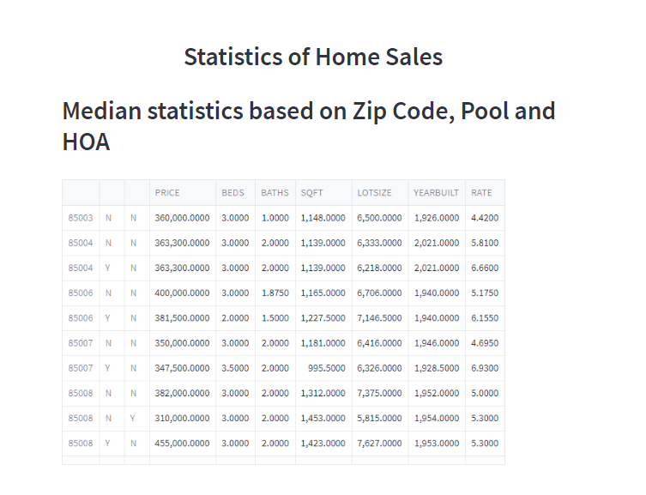

## Correlation of Home Features

The correlation of home features is a statistical representation of how each of the home features are related to each other. When looking at this heatmap, lot size and year built are negatively correlated. This means that older homes are more likely to have a larger lot size. On the positive correlation side, year built has a positive correlation to HOA as many new homes HOAs. This visualization is a quick snapshot of understanding the feature relationships.

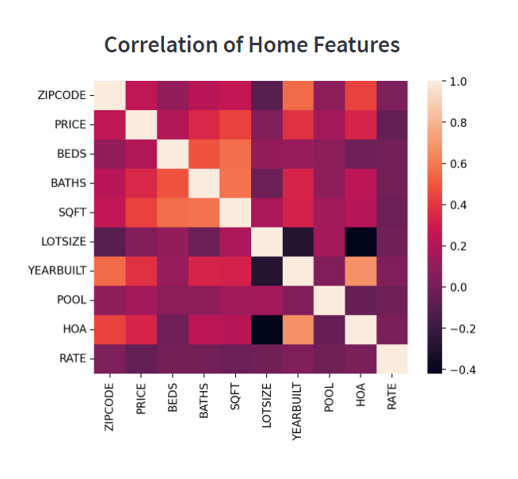

## Calculator

The calculator page is the page used to predict or calculate a home’s value based on user inputs.

Zip code: Select from the dropdown of the Phoenix zip codes

Bedrooms: Select from the dropdown the number of bedrooms from one to five

Bathrooms: Select from the dropdown the number of bathrooms from one to four including half baths.

Square Footage of House: Enter the square footage of the house. The minimum square footage allowed is 500sqft and the maximum allowed is 3,500sqft.

Lot Size: Enter the square footage of the lot. The minimum value allowed is 3,500 square feet, and the maximum value allowed is 15,000sqft.

Year Built: Enter the year the house was built with a minimum year allowed of 1915 and a maximum year of 2023.

Pool: If the property contains a pool, select the checkbox.

HOA: If the property is part of an HOA, select the checkbox.

Rate: The approximate 30 year fixed mortgage rate expected.

Once the data is entered, select the Calculated Predicted Price button at the bottom of the form and the model will produce a predicted price.

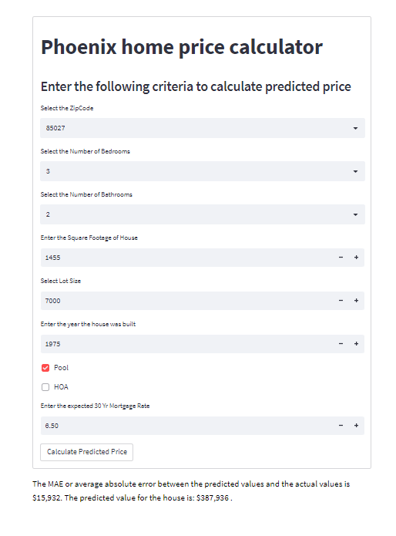

## Troubleshooting

**Failure to load**

Should the app pages fail to load, close the browser page that the app is on and reopen the app from the shared URL. If after closing the app and browser the app still does not load, please try another device, or contact the owner of the app.

**Missing sidebar**

If the sidebar appears to have disappeared, click on the small arrow in the top left of the screen to show the hidden sidebar.

## FAQ’s

**How to change viewer theme’s**

On the top right corner of the app select the three bars  and open the settings option. From here, there is the choice to view the app in light or dark mode based on user preference.

**How to view maps and visualizations on full screen**

Each of the visualizations and graphs can be expanded by clicking on the arrows in the top right corner of the map or visualization

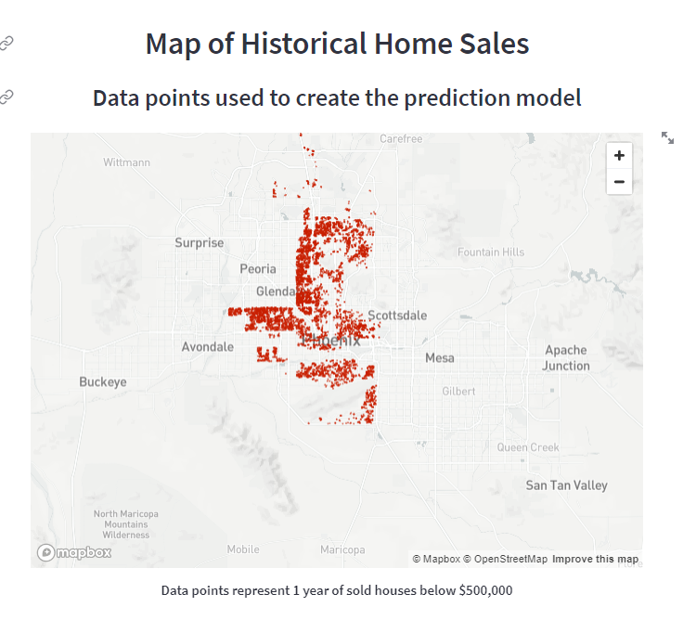

**How to view charts and visualizations across the width of the screen without using full screen**

On the top right corner of the app select the three bars  and open the settings option. From here click on settings and select ‘Wide mode’ under Appearance.

**How to hide the sidebar to increase the viewing screen.**

Click on the x in top right corner of the sidebar to hide the sidebar. To bring the sidebar back, click on the small arrow in the top left corner of the app screen.

## Help and Contact Details

For help with this app, please contact the app owner at dbelbin@my.gcu.edu

# System Administrator Guide

The Phoenix price predictor model begins in Python with the model built in a Jupyter notebook called Cap.ipynb. Within the project there are also pages of python code for each page of the Streamlit app including: Homepage.py, Page1.py, Page2.py, Page3.py, Page4.py and prediction.py. Lastly there is the app.py page which compiles each of the Streamlit pages into one app. The following guide will walk through updating the data as well as the model from Python to Streamlit.

The repository can be found at GitHub: <https://github.com/dbelbin/Capstone.git>

The app can be found at Streamlit App: <https://dbelbin-capstone-app-mp6x0y.streamlit.app/>

## Adding New Data

To keep the model current and ensure that the accuracy of the model is maintained, it is important to add new data every three months. The data for the model is downloaded from Redfin in batches of up to 350 properties that are single family homes that have sold for less than $500,000 in a City of Phoenix zip code. When there are more than 250 properties that have sold in the previous three months, the data can be downloaded by zip code with up to five zip codes in each search.

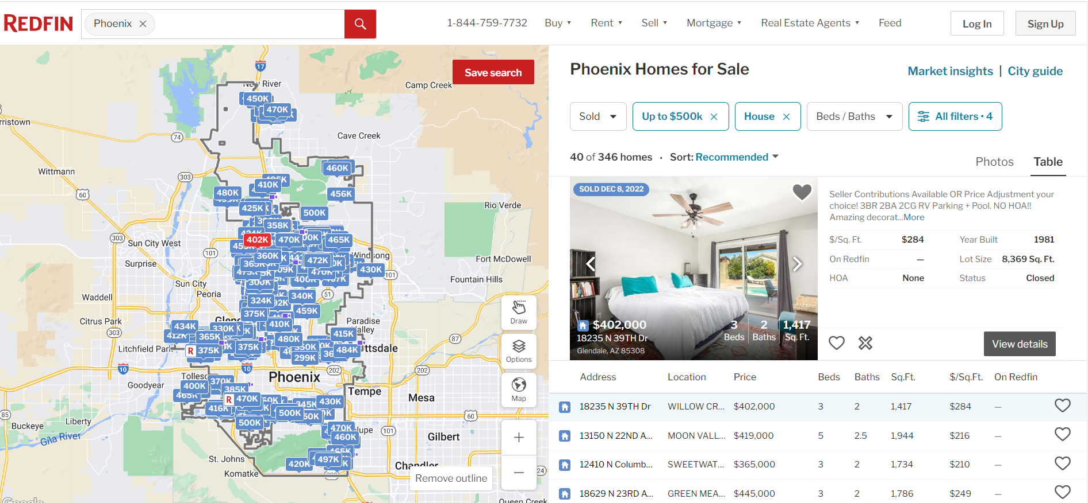

Using the download all feature, the non-proprietary fields will be downloaded into a csv file.

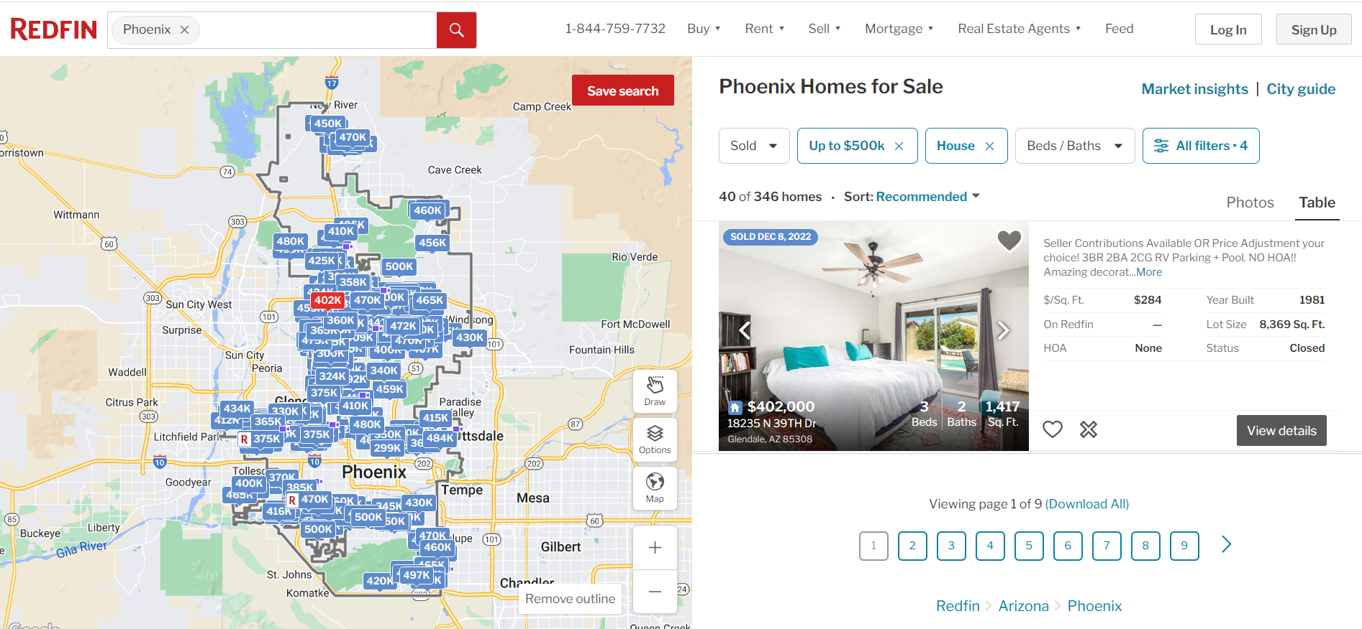

These files will need to be moved into the working directory of the model for the model to ingest and process.

The second set of files are downloaded from the Freddie Mac website by week. The data is downloaded into an excel file. There are two data fields used from this download, the week date and the US 30 yr. FRM fields. These fields need to be expanded to the day level and copied into the historicaldata.xlsx file that is stored in the same directory as the model.

## Updating the Model in Python

The model is built on approximately 13 months of data. Depending on the macro-economic environment, the length of history used to train the model can be adjusted as needed. Within the model, locate the ‘Adjust time frame of historical data used in the model’ section and update the begin date for the data to be used to train the model.

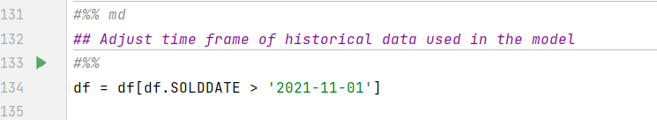

Once the has been updated, run the model. This will retrain the model and build the pickle files that will be used within the Streamlit Python pages.

## Updating the Model in GitHub

Once the data has been updated and the model has been retrained, the new model and files must be uploaded into GitHub. This is done through GitHub desktop which will determine if there have been any changes to the files in the GitHub cloud repository and if so will push them to the repository once the changes have been committed.

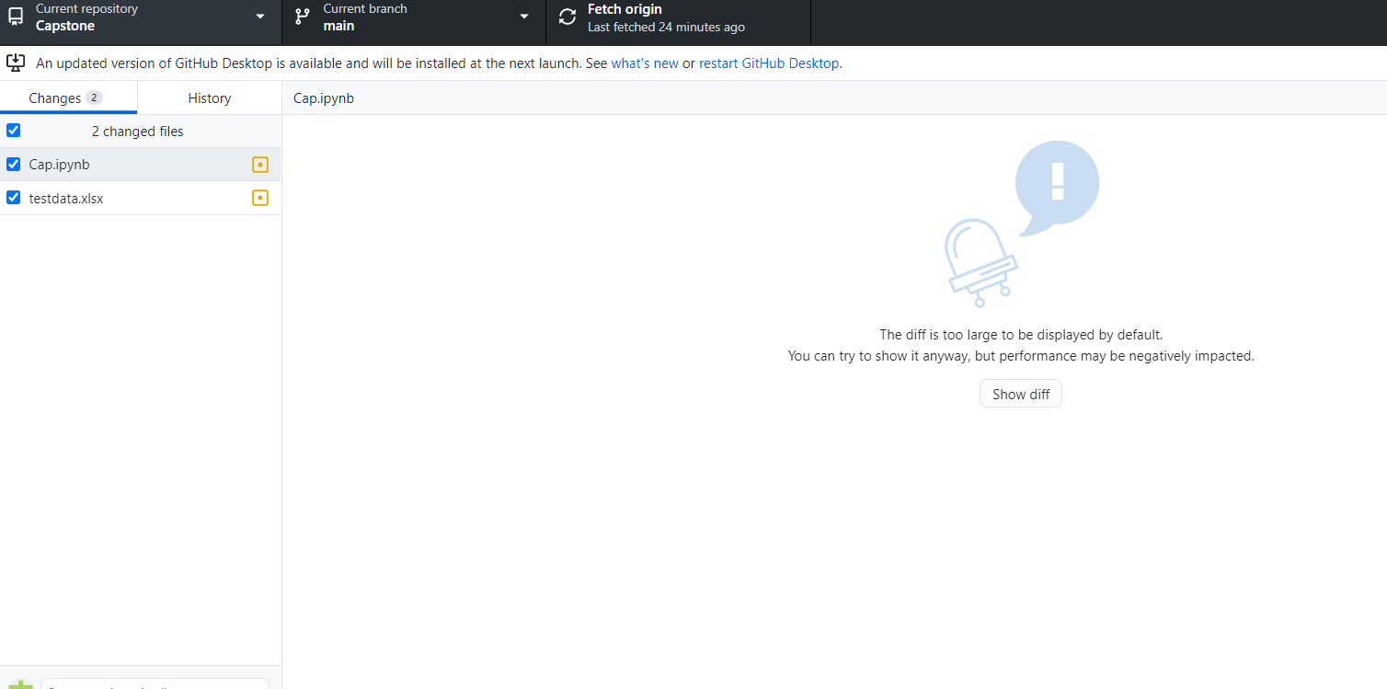

Log into the GitHub repository at github.com/dbelbin/Capstone and validate that any file changes have been updated.

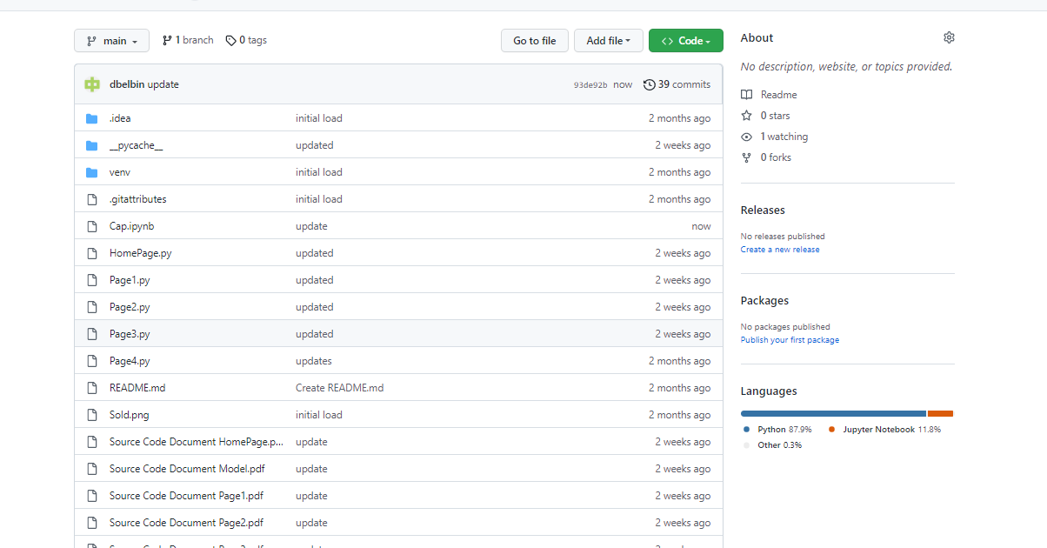

## Updating the Model in Streamlit

The Streamlit app is connected to GitHub and will automatically update with any changes that are pushed to GitHub. To ensure the model is working as intended, log into Streamlit with the login that is connected to GitHub. If the app has not had activity, it will have an inactive status. To activate the app again, click on Yes, get this app back up!

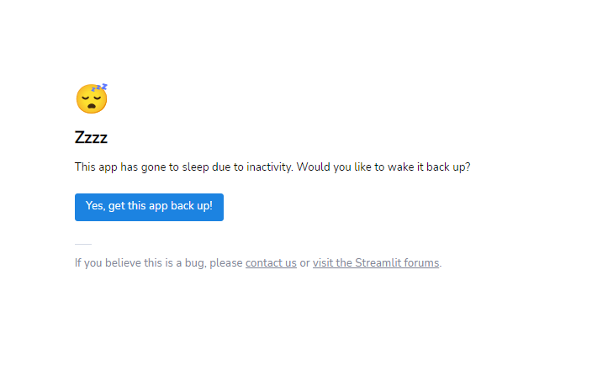

This will reactivate the app and update the content with any changes made to the model.

# References

Belbin, D. (2023). *GitHub – dbelbin/Capstone.* GitHub. <https://github.com/dbelbin/Capstone>

Belbin, D. (2023). *Capstone.* <https://dbelbin-capstone-app-mp6x0y.streamlit.app/>

FreddieMac, (2023, February 9). *Mortgage Rates.* <https://www.freddiemac.com/pmms>

GitHub. (n.d.). *Create & Manage repositories.* Git Hub Docs. <https://docs.github.com/en/repositories/creating-and-managing-repositories/about-repositories>

Geeks for Geeks. (2022, November 7). *Data Science Apps Using Streamlit.*Geeks for Geeks. <https://www.geeksforgeeks.org/data-science-apps-using-streamlit/>

Redfin. (2023, February 10). *Phoenix Homes for Sales.* <https://www.redfin.com/city/14240/AZ/Phoenix/filter/property-type=house,max-price=500k,include=sold-3mo,pool-type=private>

Streamlit. (n.d.). *Streamlit Library.* Streamlit. <https://docs.streamlit.io/library>